**ITMD 513 – Open Source Programming – Python**

**Cryptocurrencies Prediction and Analysis System**

By,

Archana Subramaniyan,

A20410422

**Table of Contents**

**1. Introduction and Motivations** 3

**2. Requirement Analysis** 3

**3. Data for Project** 3

**4. Application Design** 3

Login 3

Register 3

Prediction 4

Visualization 5

**5. Workflow** 5

Login 5

Register 5

Menu 6

Prediction 6

Visualization 6

**6. Sample run** 7

**7. Extra-Credits** 37

**8. Conclusion** 37

**9. Limitation** 37

**10. Potential Improvements** 37

# **1. Introduction and Motivations**

Cryptocurrencies are being the buzz word that every individual in the world is talking about. What are they? Why a need for such coins trading apart from the traditional stock trading? How good is it to trade these coins? Are they profitable? Will I be able to predict the future price of these coins so that I can work on an investment plan? Will I become a billionaire if I buy few of these coins? etc., are very few of the huge list of questions that a majority of the population are having when it comes to “cryptocurrencies”. It is a curiosity that arouse of all these questions, the reason for coming up with this project.

# **2. Requirement Analysis**

Two major requirements for which the project is built, are:

1. predict the future price of the 3 of the top 10 crypto currencies – Bitcoin, Ethereum and Litecoin
2. Build a visualization option to visualize the distribution of various aspects of the different crypto currencies

# **3. Data for Project**

**For Prediction:**

For predicting the future price of Bitcoin, Ethereum and Litecoin, we used the up-to-date from ‘www.coinmarketcap.com’ by scrapping the daily data

**For Visualization:**

We used different datasets from another datasets repository site ‘www.kaggle.com’

**Note:** all data files used in this project will be provided in the final zip folder for reference

# **4. Application Design**

The application is built in python with the GUI based on Tkinter package.

## Login

User enters his username and PIN if he has already registered in the system. Two-step verification is carried out for validating the user. User is asked to enter PIN and access code. User is logged into the system and is allowed to access the application only when the PIN and access codes match. The validation is done against the users data stored in a SQLite Database

## Register

Users can register themselves for accessing this application. Users data are maintained in SQLite database.

Application provides user with two major categories of operations – prediction and visualization

## Prediction

A generic function was constructed to web scrape the coins data using the built-in html web scrapping function in python. The read data is then stored in csv file which is later used for building a prediction model for predicting the future price of the respective coins.

**Choosing the right prediction model:**

On analyzing the cryptocurrency coins data, it was obvious that huge effort would be required to clean the data and set it up ready for building the prediction model.

Since coins data is a time-dependent data we cannot go with a regression model since it would not be appropriate to use them for predicting time-based data.

Time series model was to be built to predict the future price of coins. Time series models like MA (Moving Average) model, AR(Auto-Regressive) model, ARIMA, ARMA models are primarily used for stock price predictions.

But when trying to use these models for building a prediction model for crypto coins, it failed. Reason is, all these traditional time series models can be used only for normally distributed data.

These crypto coins data are not normally distributed. Even after applying different transformations like log and inverse transformation, even after applying differencing , it was difficult to transform the coins data to a normally distributed data.

It was even difficult to decide about the lags to be used for time series models, since the stationarity assumption was also not satisfied by the coins data

While researching for an appropriate model to fit on the coins data, we found that LSTM – Long Short Term – model of neural networks came to the rescue.

Yes, LSTM model fitted on coins data and the predictions were near accurate. Hence we built LSTMs to predict the future price of bitcoin, Litecoin and Ethereum

**LSTM:**

LSTM is Long Short -Term Memory. This is more like an improvised version of RNN. Recurrent Neural Networks. Recurrent Neural Networks are mostly used for solving/analyzing sequential data. Stock data, for example, can be predicted based on various features like volume, open price, market cap etc., but it can also be predicted based on the previous stock prices.

This dependency on previous data and using these previous time data to predict the future price is what RNN is all about. RNN works in such a way that while trying to predict the price for today, it first reads all the previous days’ data and learns the data to build a model for predicting today’s price.

Neither the whole data is fully useful nor fully useless for building a prediction model. Few of data would be very crucial for building a model which should be considered for creating a model whereas few of the data may not be useful which should be skipped from creating a model. It is this feature that RNN was missing. RNN does not have the capability to differentiate useful and useless data on its own. Every time, it takes the entire data to build the prediction model which ultimately affects the performance of the model thereby affecting the accuracy of prediction.

It is to overcome this problem, LSTM were introduced. LSTMs can differentiate useful and useless data, adjust to make the data useful and they even can selectively remember or forget portions of data for building a better prediction model

LSTM models in python are built using the keras package. The input data in CSV file is converted to a dataframe and is then reshaped to be suitable for LSTM model

The model is fit over 300 epochs with different batch sizes for bitcoin, Ethereum and Litecoin data. And since it takes 300 epochs to train the data for fitting to a LSTM model, this prediction would take more time than other prediction models which is the only disadvantage of LSTM.

## Visualization

Different plots for visualizing the various aspects of cryptocurrencies are drawn using the matplotlib and seaborn packages. Different charts that can be generated in this application are:

Barchat exhibiting the comparison of average volume of different cryptocurrencies

Scatter plot presenting the yearly average price distribution of different cryptocurrencies against the different years from 2013 to 2018

Box plots for comparing/viewing the High price distribution of different cryptocurrencies

Datasets from Kaggle.com are used for this category of operations

# **5. Workflow**

## Login

User enters username and PIN first. Upon successful validation of this combination, user is asked to enter the access code. Access code and PIN combination is then validated to allow the user to enter the application.

User is prompted with appropriate error messages when he does not enter username or password or access code and when he enters an invalid username or password

## Register

User enters all the required data and clicks register to register into the system. Upon successful validation of all the fields, the user details are entered into the system. User’s pin is hashed and then stored in the database.

Even while logging, the pin entered by the user is hashed and only then validated against the hashed pin in the database

## Menu

After the user logs into the system, the user is provided with a menu Frame that has predictions and visualizations as two categories.

## Prediction

Under prediction, he can choose to predict the future price of bitcoin, Ethereum and Litecoin

User enters a future date and clicks on respective button for prediction. As mentioned earlier, since 300 epochs were used for training the LSTM model , it takes much time to finish the prediction. User is prompted to wait to get to know the predicted price.

On successful prediction, tomorrow’s price is thrown to the user in the messagebox irrespective of any future date the user has given.

It then throws the prediction frame which presents the predicted price for the date entered by the user, predicted price of today, predicted price of tomorrow and yesterday’s price.

If the user wants to know the price of the coin at that very specific moment, the user has an option too. He will be take to the respective coin page in coinmarketcap.com website.

User is also presented with the statistics details of the Close price of coins, a histogram exhibiting the distribution of close price of coins and a graph showing the trend of the growth of the close price of coins

## Visualization

Under visualization, user can choose either of the following:

Visualize yearly distribution : clicking this, user can view the distribution of yearly average close price of different coins over years from 2013 to 2018 which is presented in a scatter plot

Visualize volume/market cap: clicking this, user is provided with a window of coins names which the user can choose any combination of coins for which he wants to compare the average volume or average market cap . User chooses the coins from left box and clicks ‘add’ to use that coin in the comparison chart. User can click ‘remove’ button to remove any coin from the right listbox .The comparison is presented in the form of a bar chart

Visualize distribution of coins: clicking this, user is provided with a window of coins names as presented for the above option. As mentioned above, he can choose any combination of coins to view the comparison of the distribution of the high price of coins in the form of a box plot

# **6. Sample run**

Login Frame thrown first on launching the application

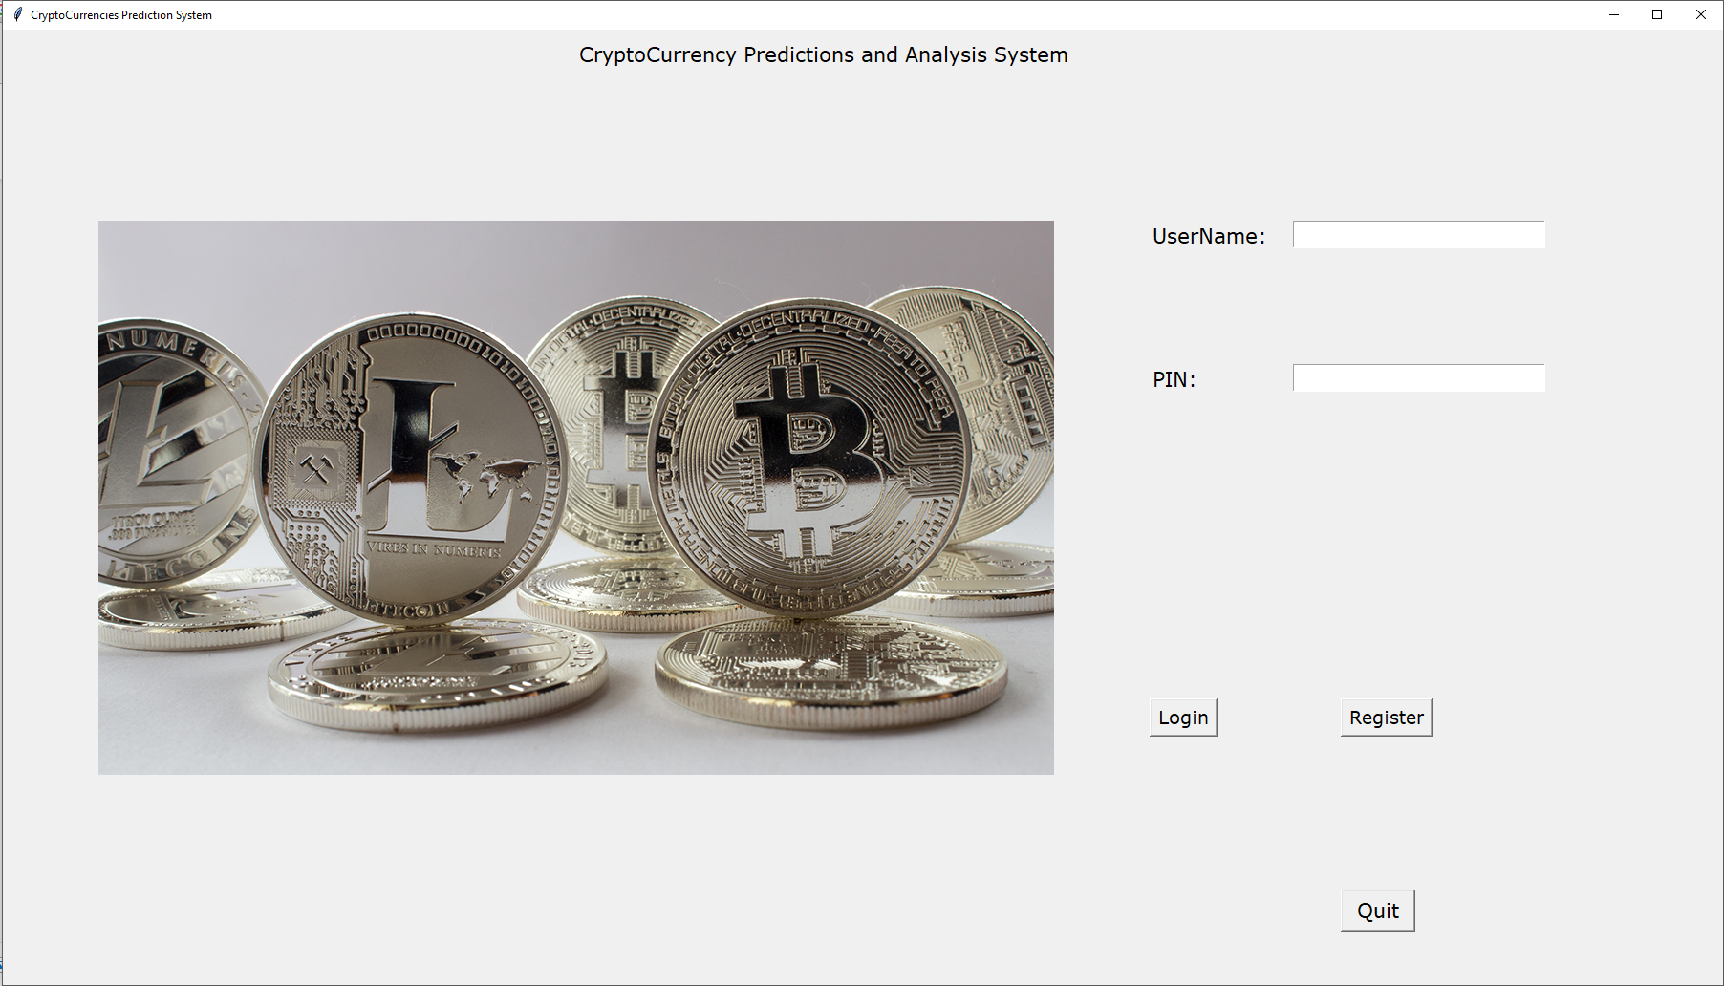

User clicks login without entering username. He is asked to enter the username by throwing a message box

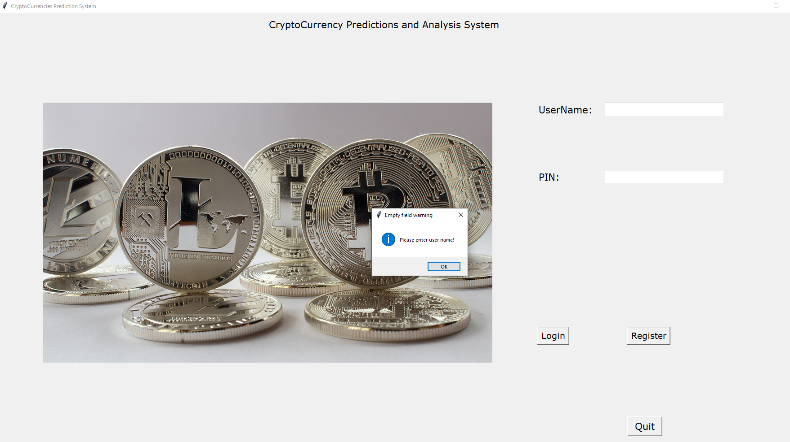

User clicks login button after just entering username. A messagebox is thrown asking the user to enter the password

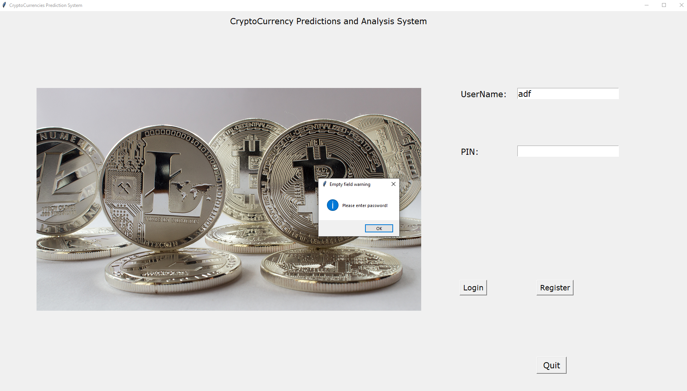

Since the entered username is not present in the database, user is informed of the same via a messagebox

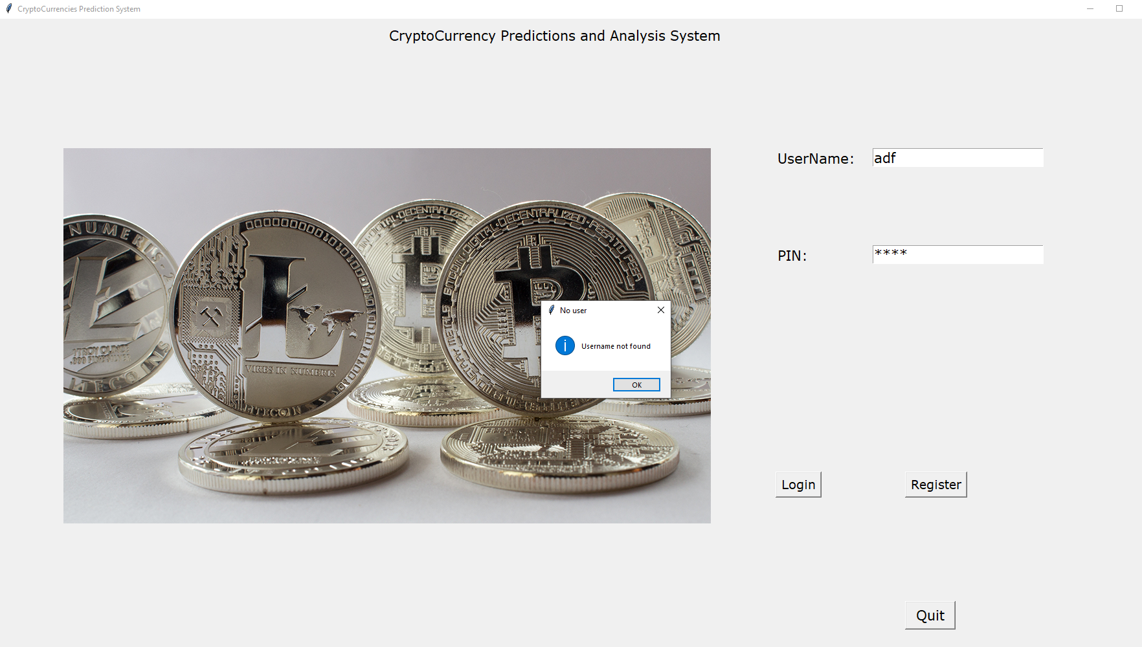

User enters the right username and password. He is informed that he has successfully logged in and he is asked to enter the access code. Access code and verify access widgets are now available for the user to enter the access code and access the application

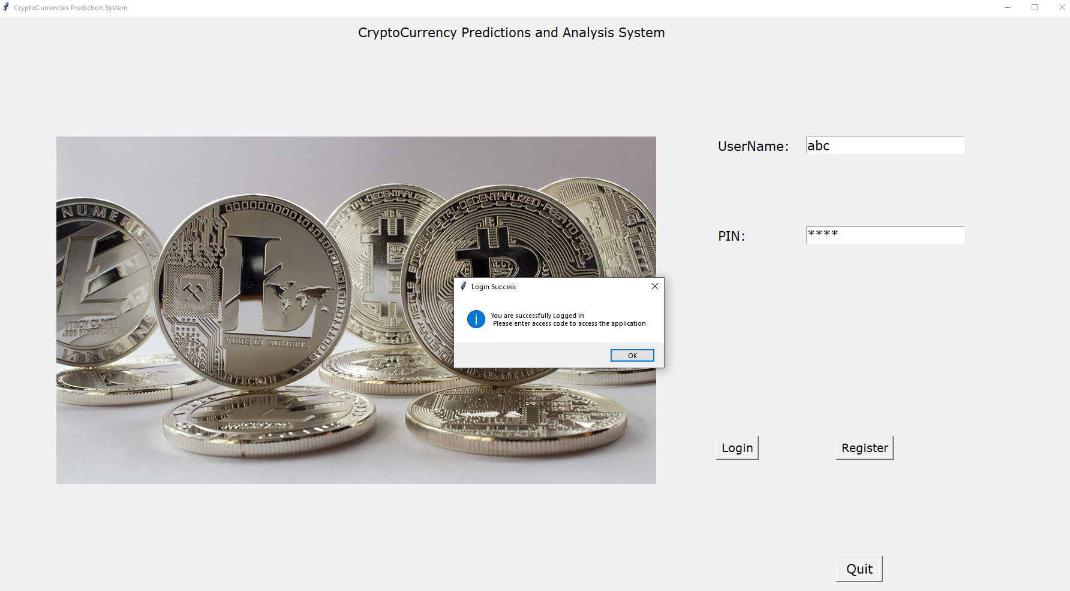

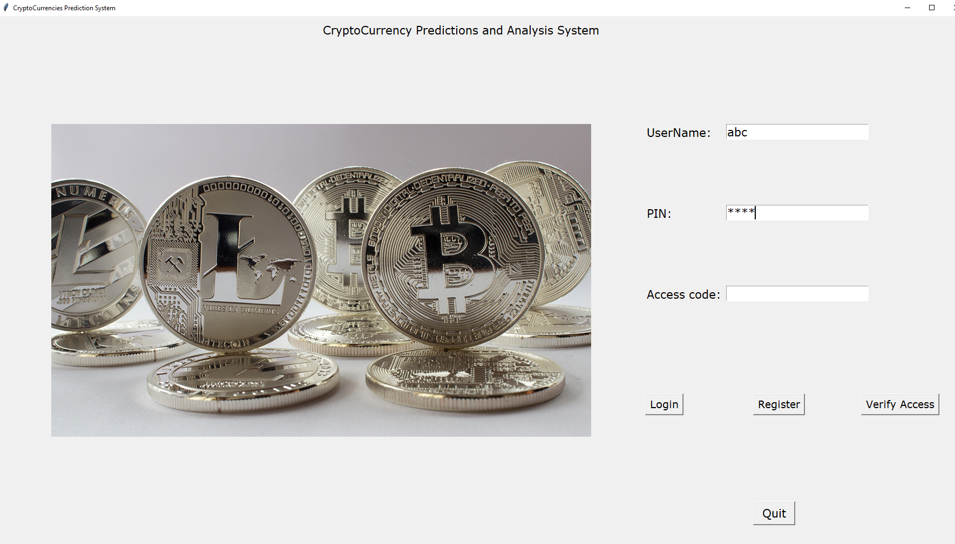

User clicks ‘verify access’ button after entering the access code. Since the access code does not match, a messagebox is thrown with the same message

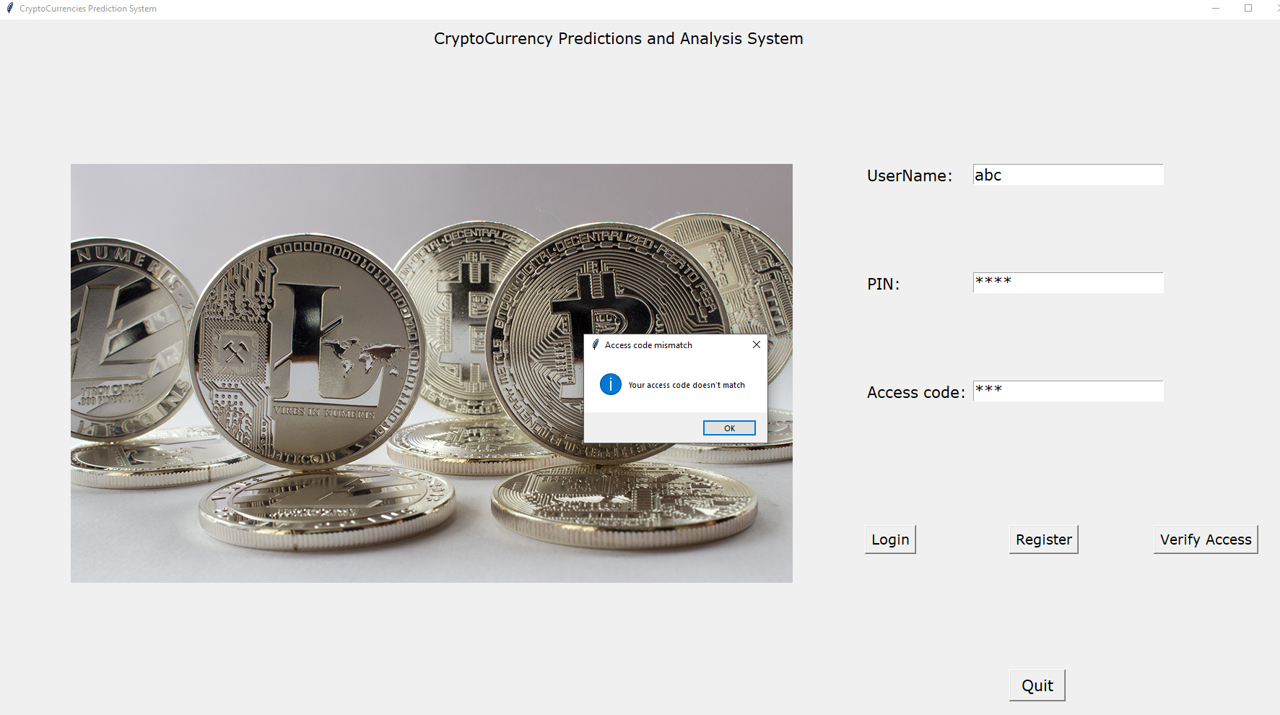

User now enters the right access code

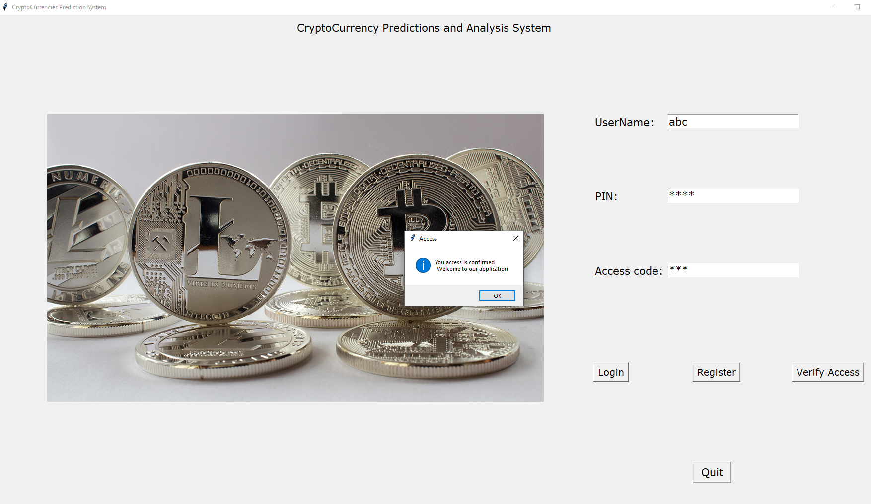

Below is the menu frame thrown to the user

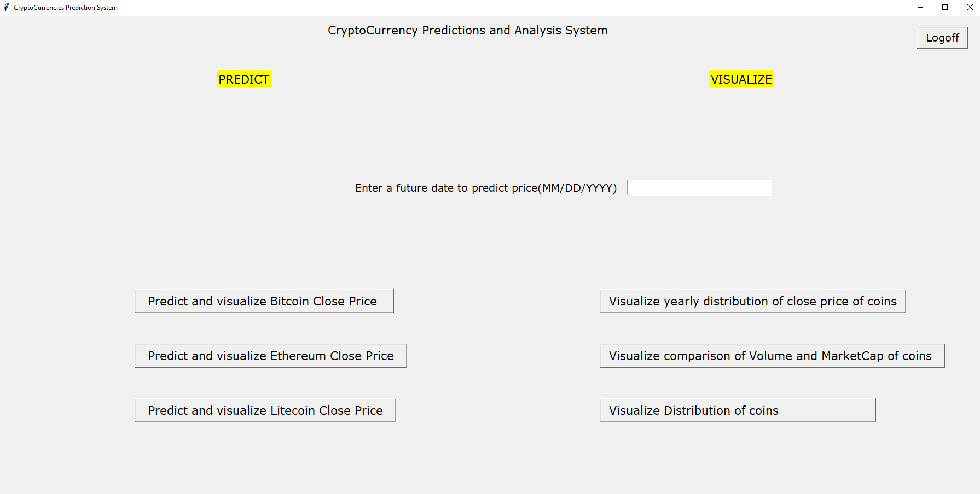

The Predict section of the frame helps a user to predict the future price of crypto currencies – Bitcoin, Ethereum and Litecoin. Visualize section helps a user to visualize the different price distributions like close price, yearly average close price, high price, volume and market cap of different cryptocurrencies.

Let’s first check ‘predict’ section. User enters a date and chooses any coin he is interested to see the future price

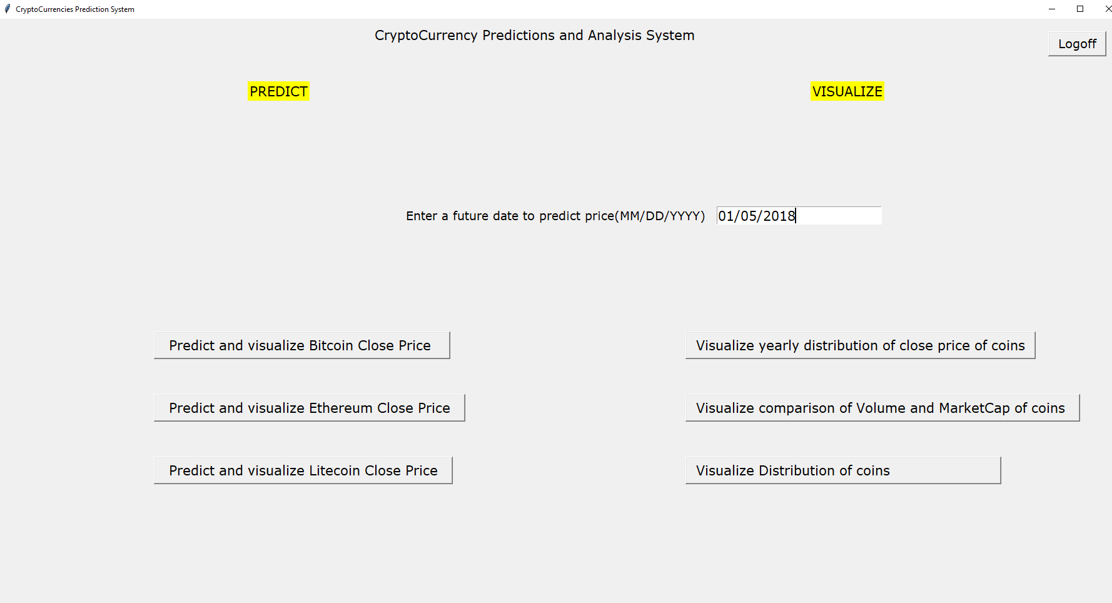

As seen, it is a past date. Prediction is for future prices. Hence user is asked to enter a future date

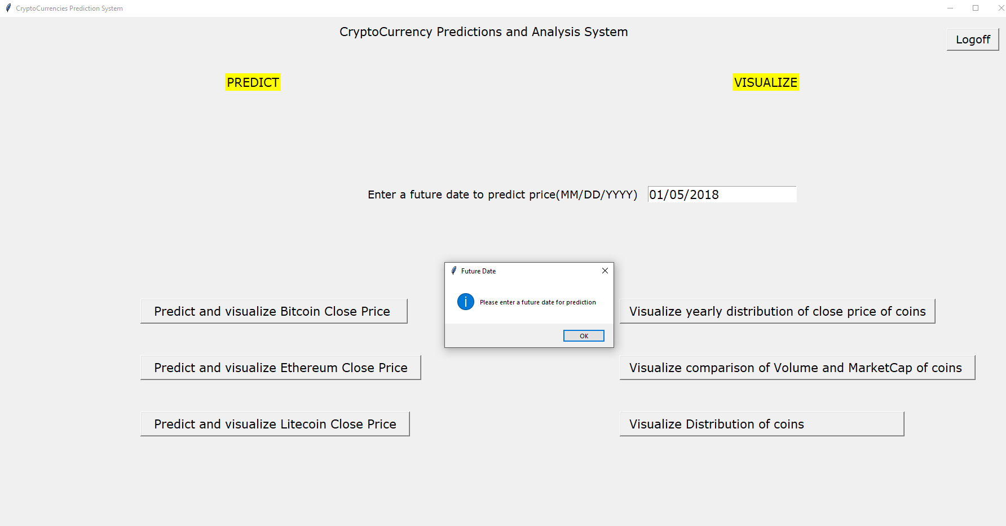

User enters today’s date. Even this is to be corrected!

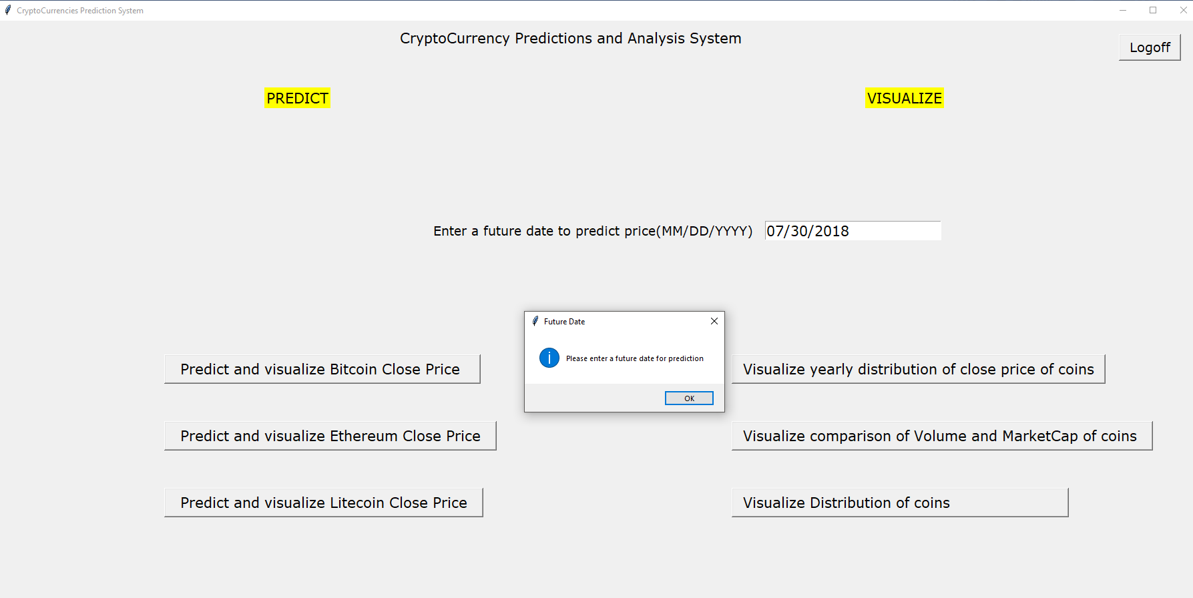

User now enters a future date for which he wants to know the price of coins. He chooses Bitcoin first to see the future price

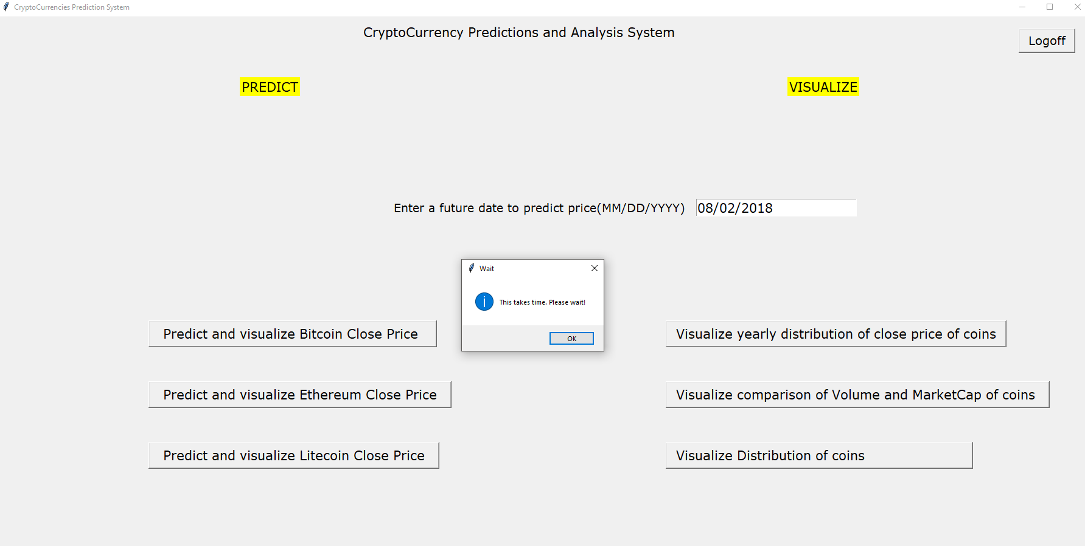

Since it has tensor flow running in the backend for this prediction, it takes time and hence the user is informed to wait for sometime



A messagebox is thrown to the user soon after the predictions are done. It says what would be the price for tomorrow. He clicks ok here to see the price for the date he wished for. This is an additional info presented to the user

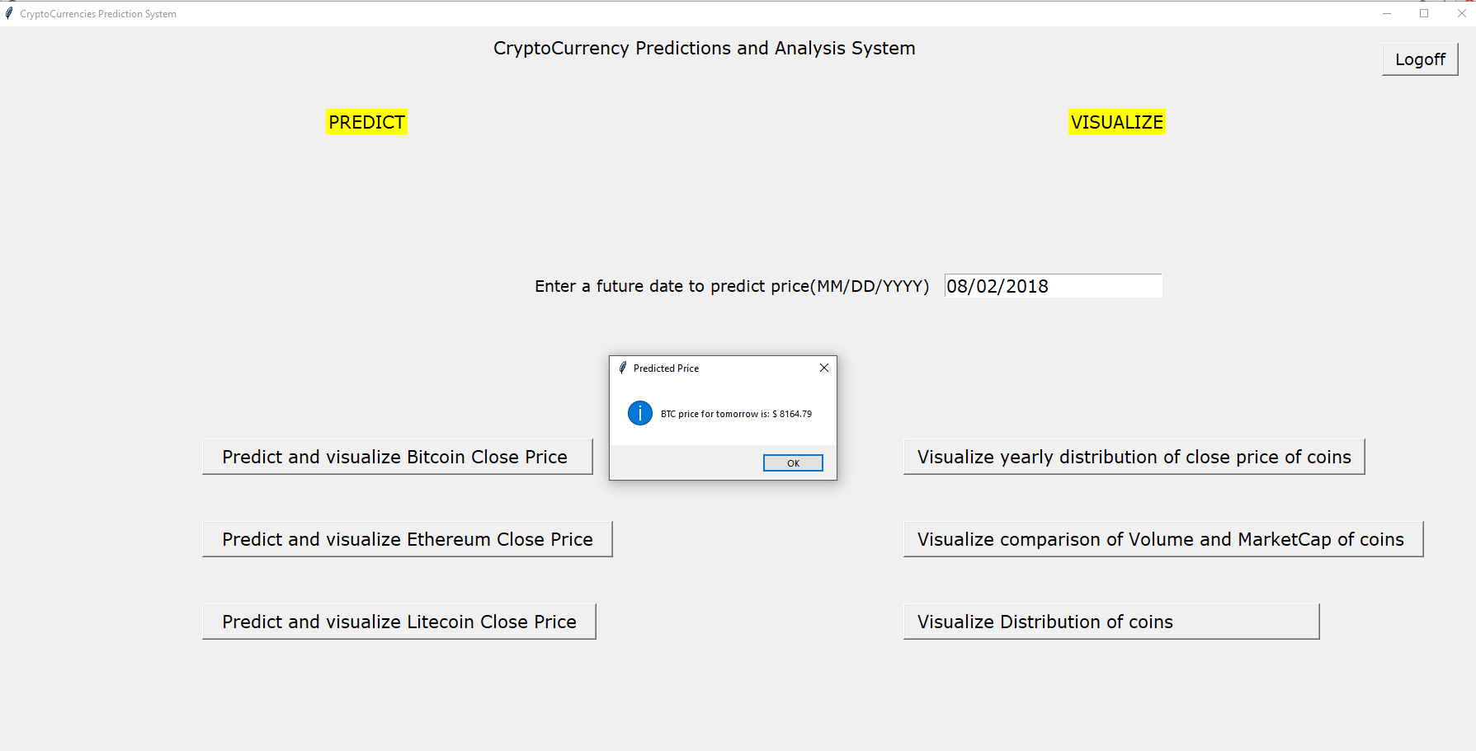

User asked just for the future price of the crypto coin. He is presented with abundant information as shown below

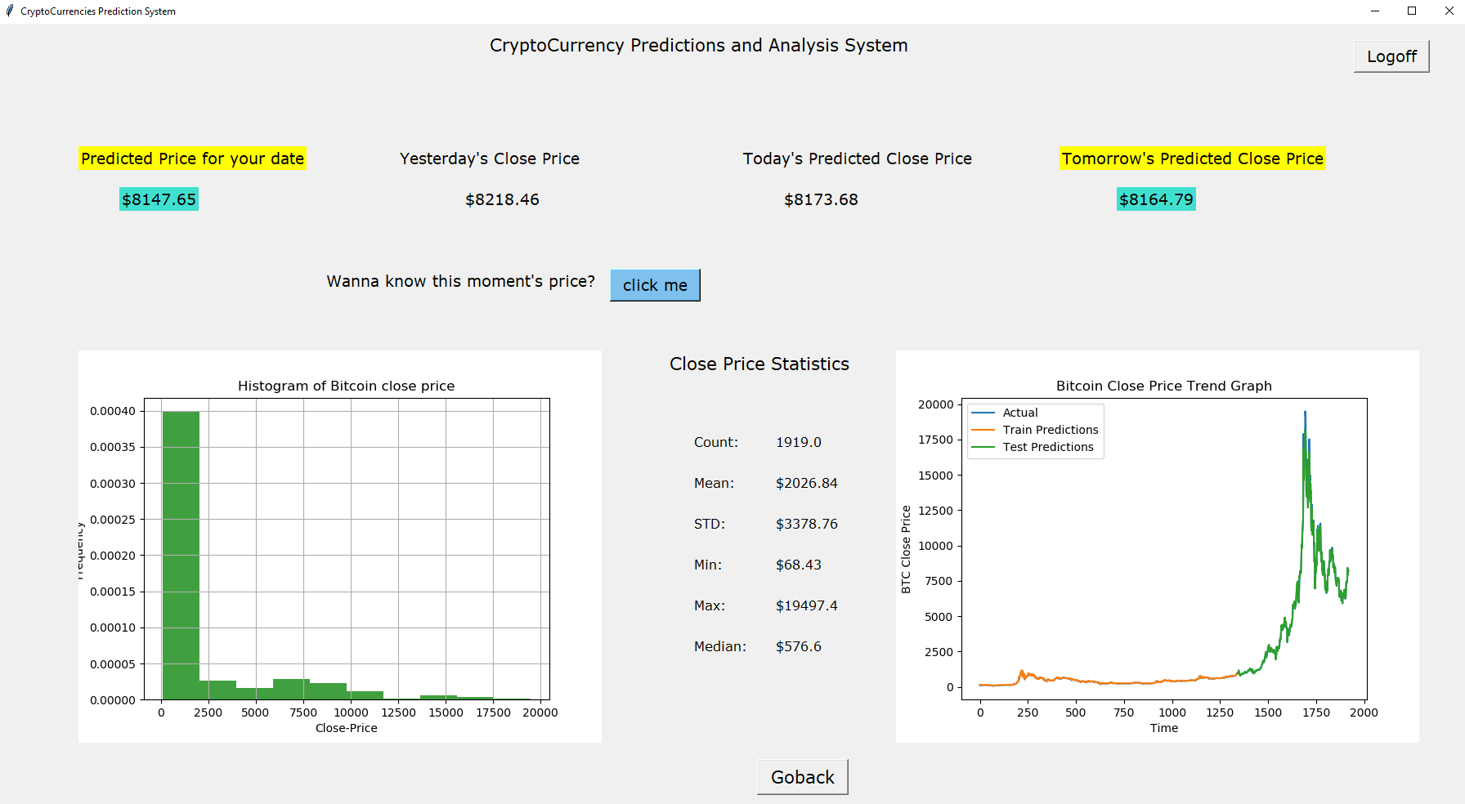

As you can see, user can now know what the close price of bitcoin on the date would be he wished to know. The application also shows what was yesterday’s price, what is going to be today’s predicted close price End of Day, what would be the price for tomorrow. He is also provided with a good visualization of the distribution of close price of bitcoin data, the growth trend of the bitcoin close price and the statistics of the bitcoin close price data.

Prediction model RMSE and statistics are displayed to the console:

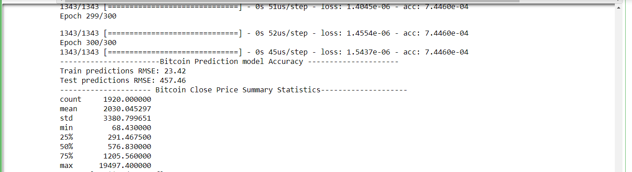

Yet another interesting feature presented here is the ‘click me’ button. As you can see, user can even see what the price of bitcoin at this very moment by is clicking this ‘click me’ button. This button takes the user to the bitcoin webpage on coinmarketcap.com website by opening it in a web browser

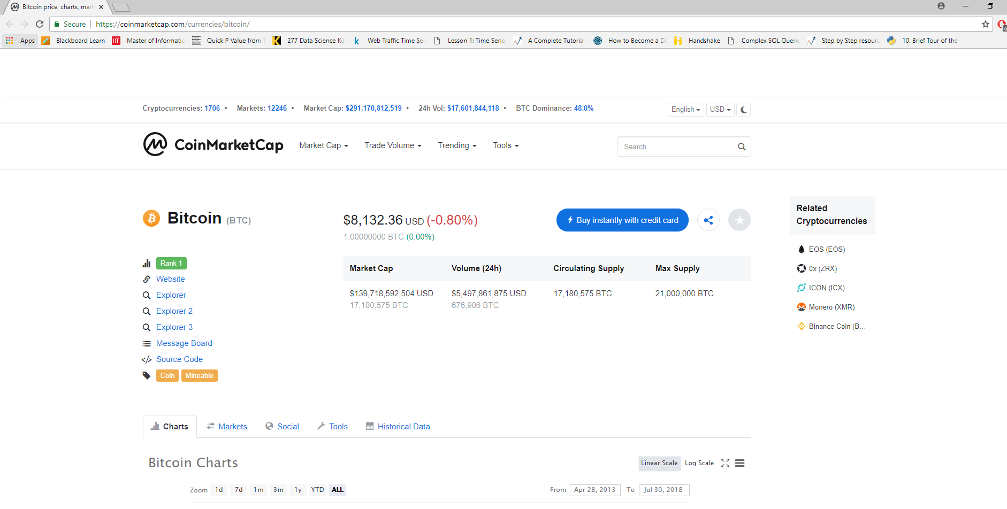

Let’s go back and have a look at the other two cryptocoins as well. User clicks ‘go back’ and he is taken to this frame below. User now chooses to see the future price of ethereum

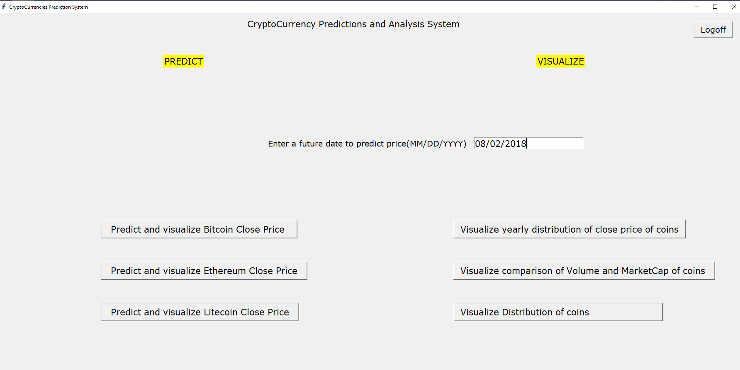

As stated earlier, the user is asked to wait for the prediction process to get over.

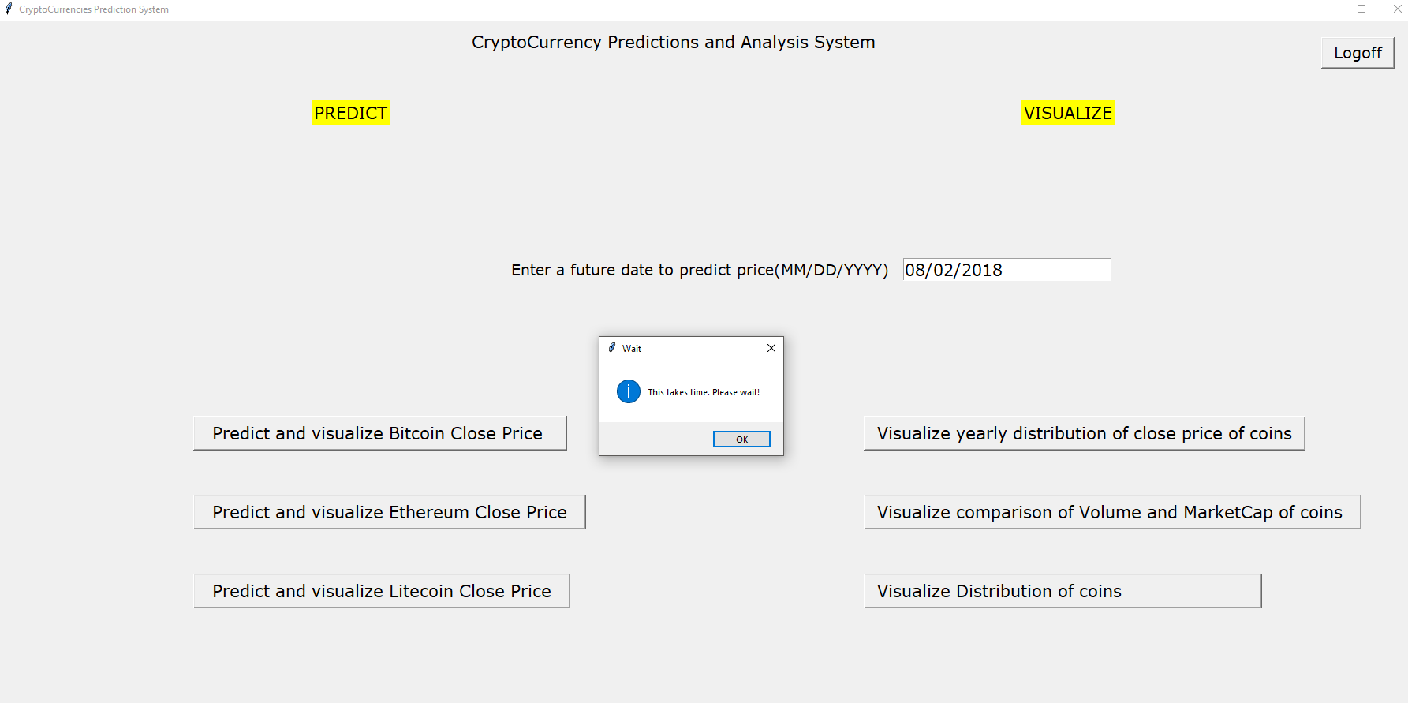

Prediction is over and is user is shown with tomorrow’s price in a messagebox. He clicks ok to see the abundant information about Ethereum

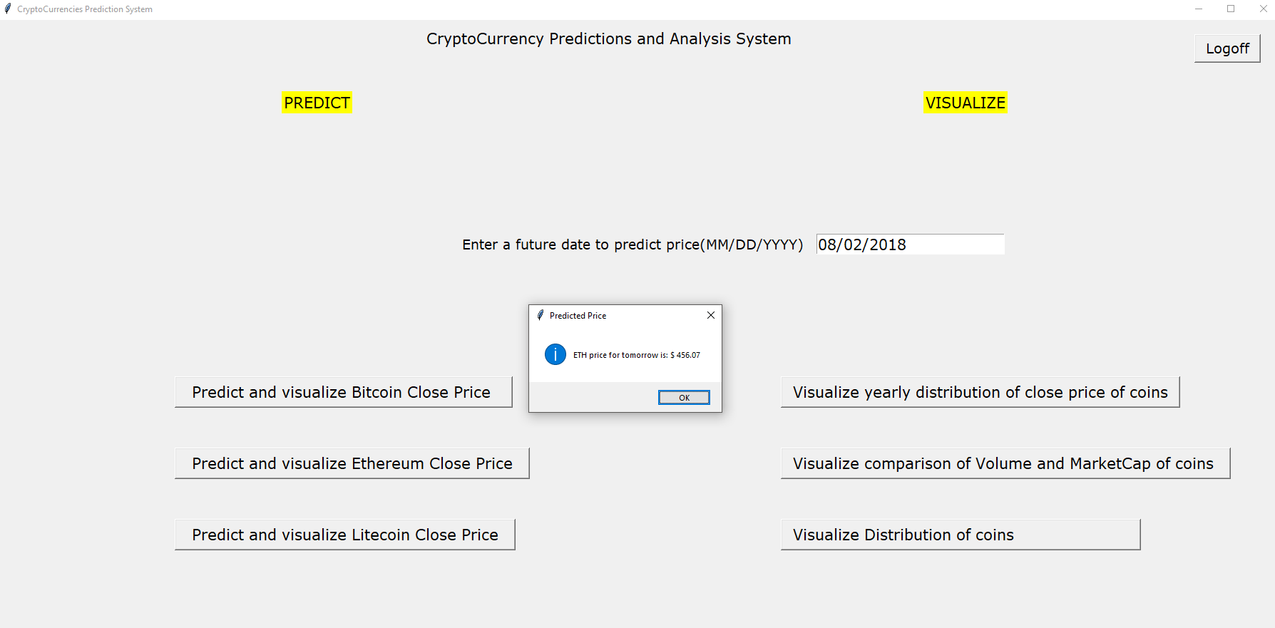

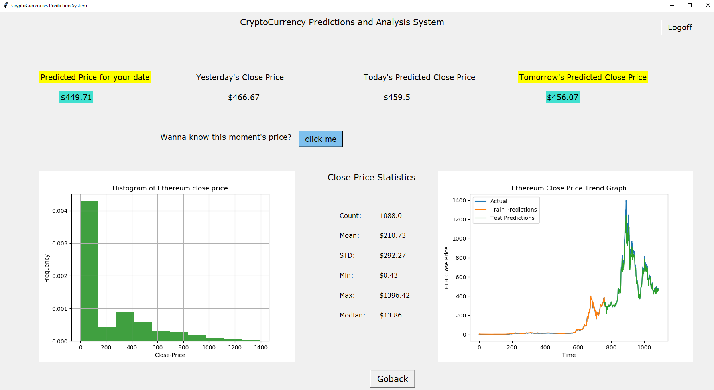

Ethereum price prediction model RMSE and statistics are printed to the console as shown below

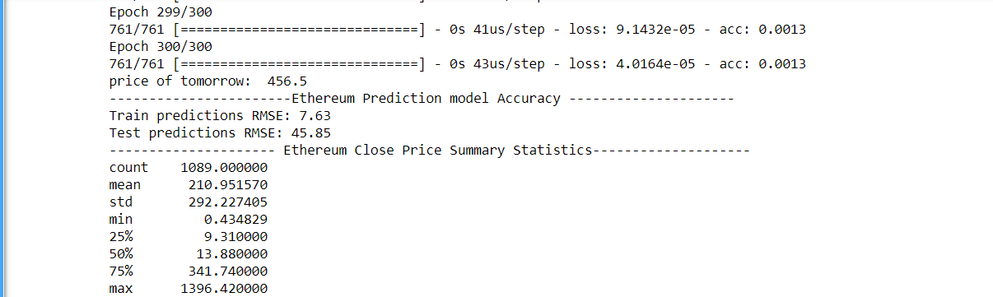

As stated earlier, predicted price plus distribution and trend plots and statistics are made available to the user in this frame. User can click ‘click me’ button to know the moment’s price as shown below

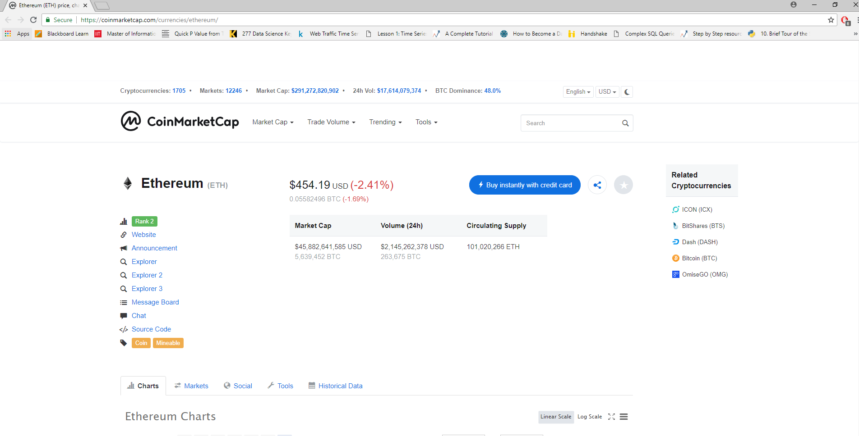

User now wishes to see future price of Litecoin. He clicks on Litecoin predict button and asked to wait

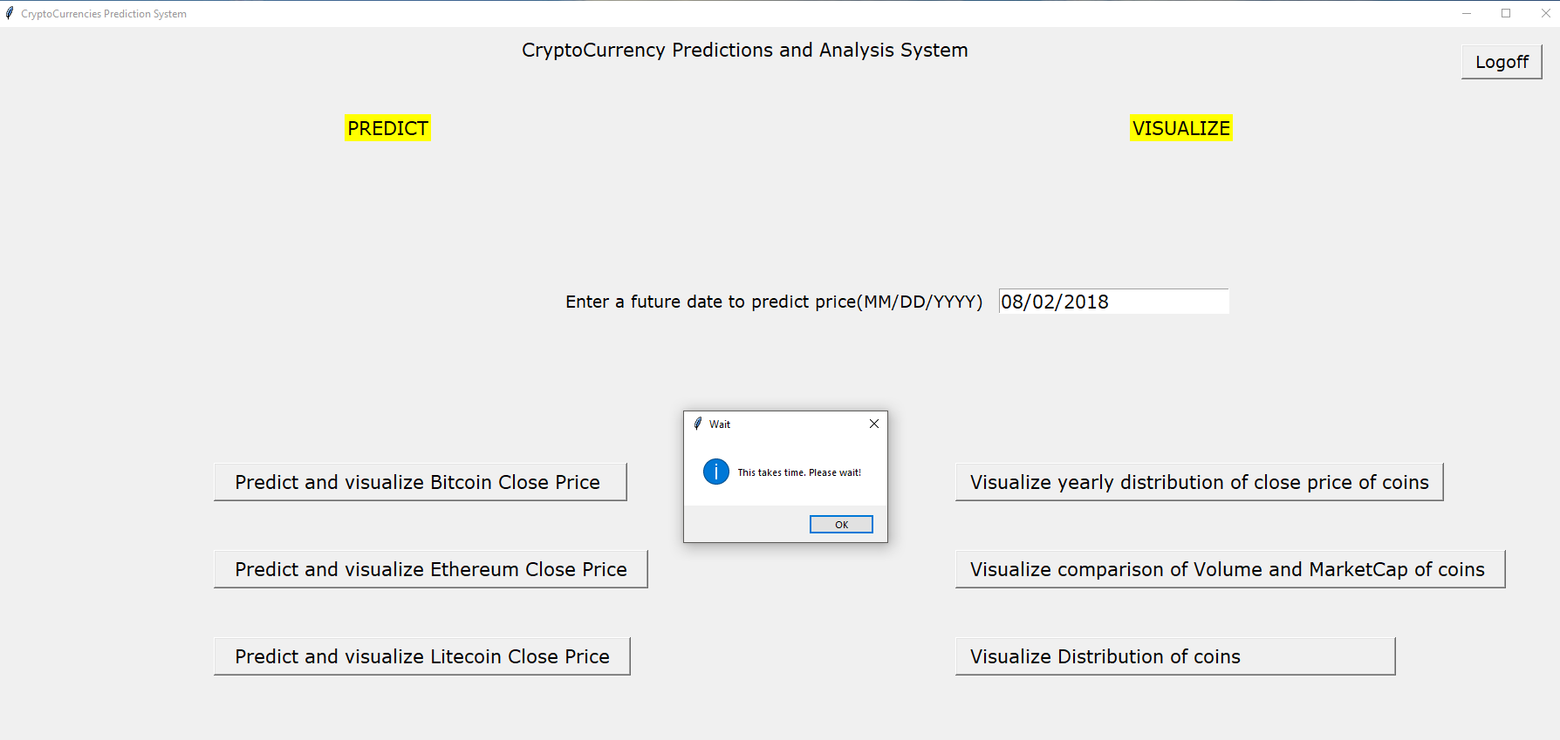

Litecoin’s tomorrow’s price is shown in the messagebox as a compliment to the user

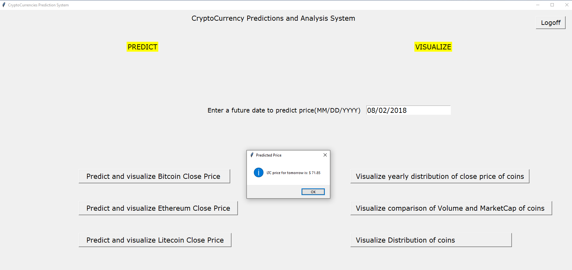

User can now see not only the price of Litecoin for his date, but also see yesterday’s price, today’s predicted price, tomorrow’s price and also shows the distribution as histogram and the growth of price as a trend plot

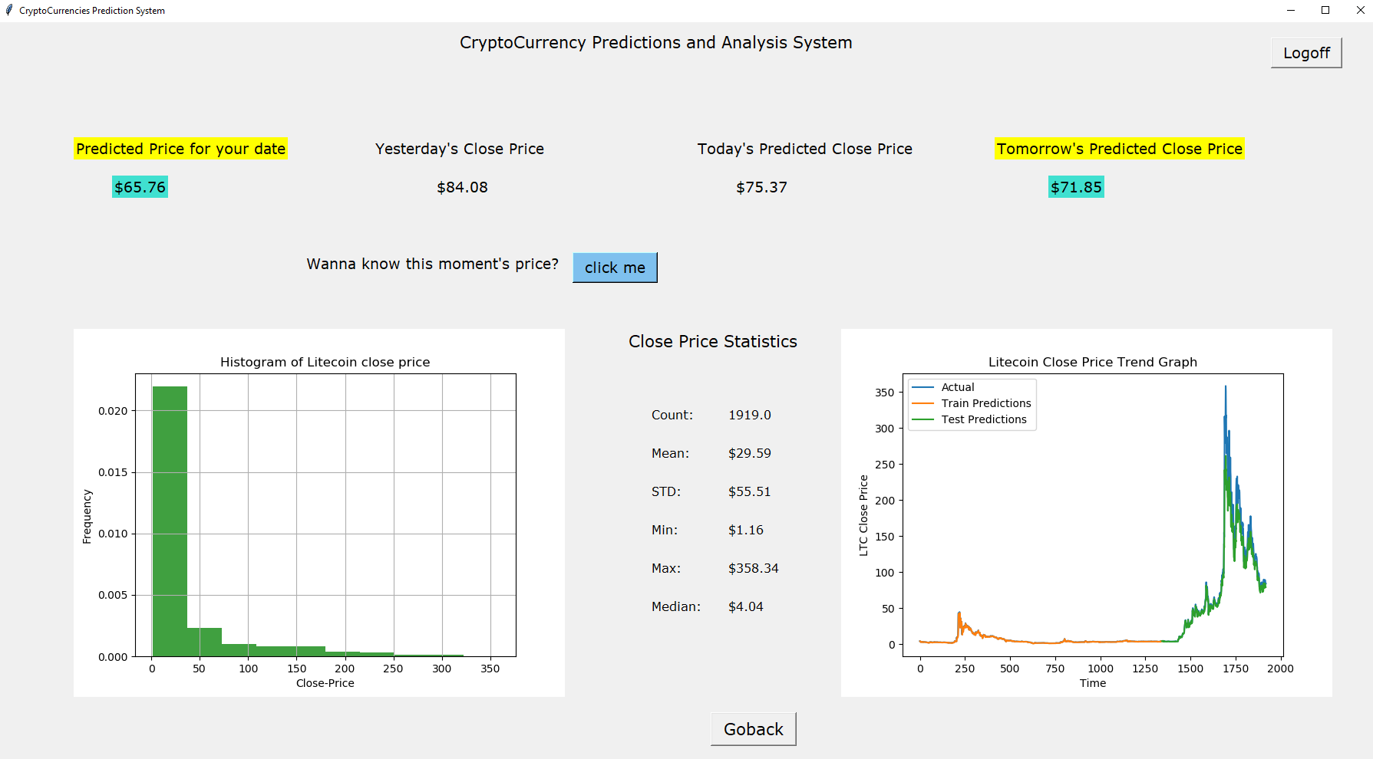

Litecoin prediction model RMSE and statistics are displayed to the console

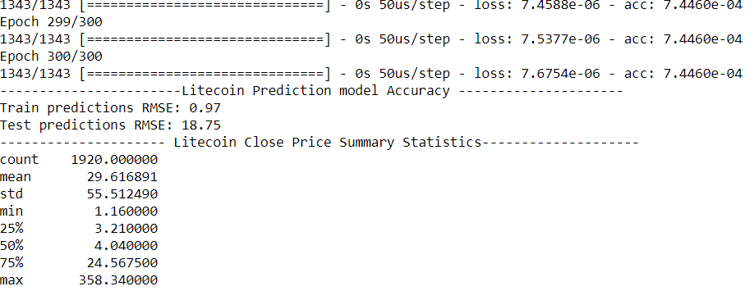

Clicking ‘click me’ takes user to the Litecoin page of coinmarketcap

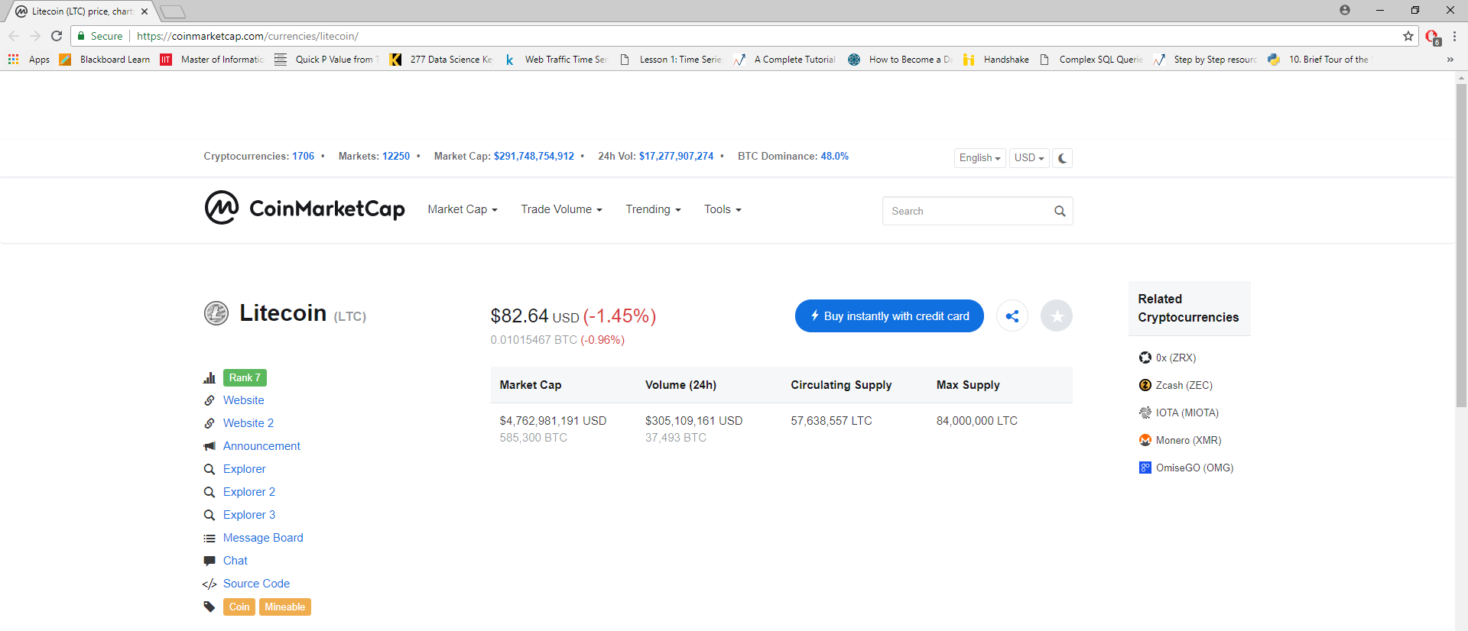

Clicking on ‘go back’ button takes the user to the menu frame as shown below

We will now explore the visualize category of the menu. Clicking on ‘visualize yearly distribution of close price of coins’ will take the user to the visualization frame where user can see the distribution of different crypto coins in the form of scatter plot

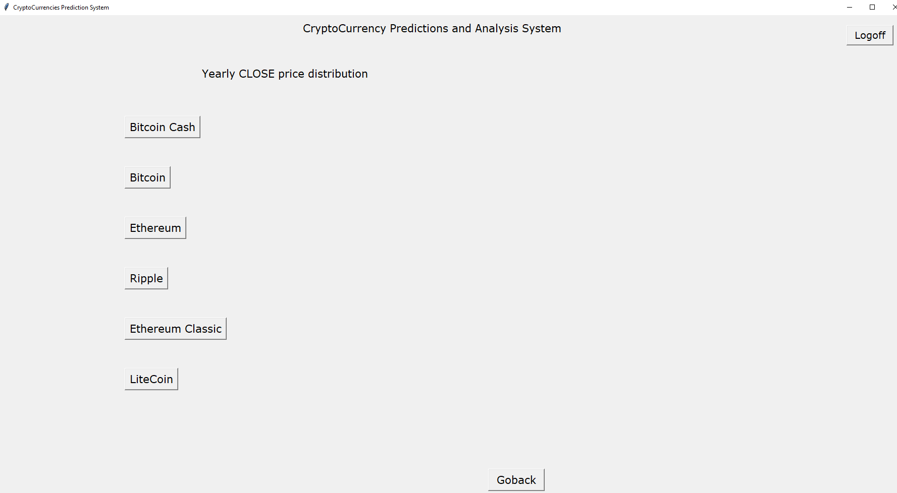

User can simply click on the different buttons to view the respective scatter plot as shown below. Ethereum yearly distribution of close price:

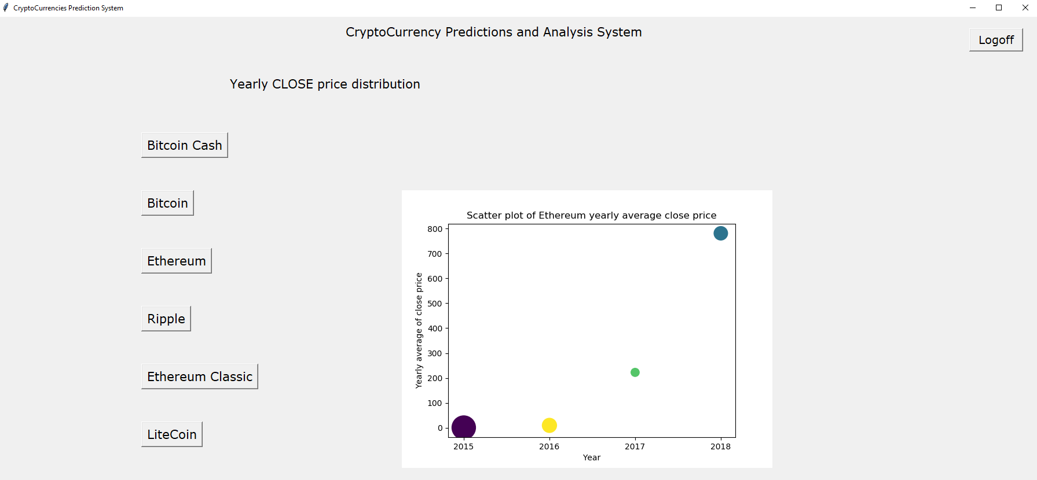

Litecoin yearly distribution of close price:

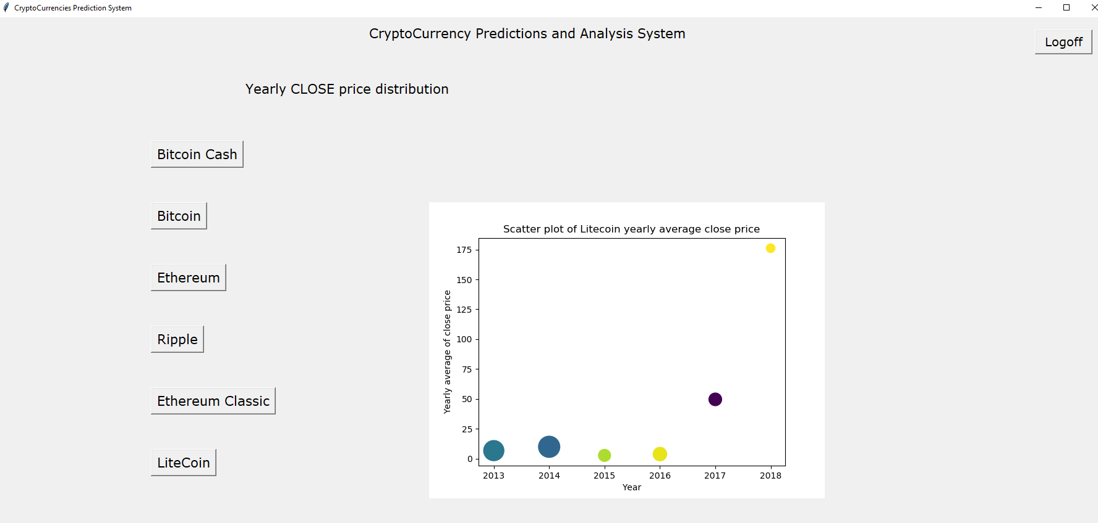

Ripple yearly distribution of close price:

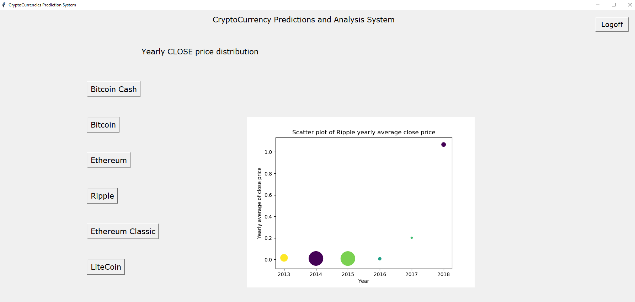

Ethereum Classic yearly distribution of close price

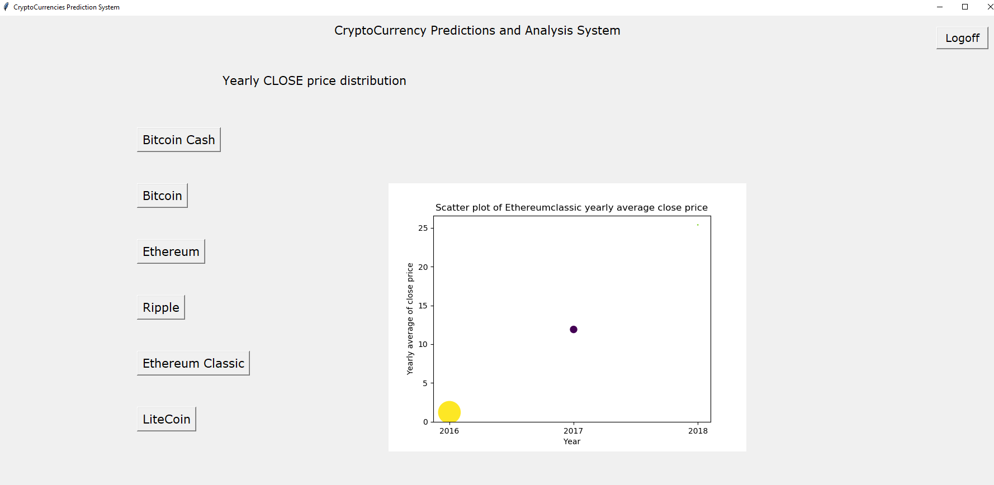

Bitcoin cash yearly distribution of close price

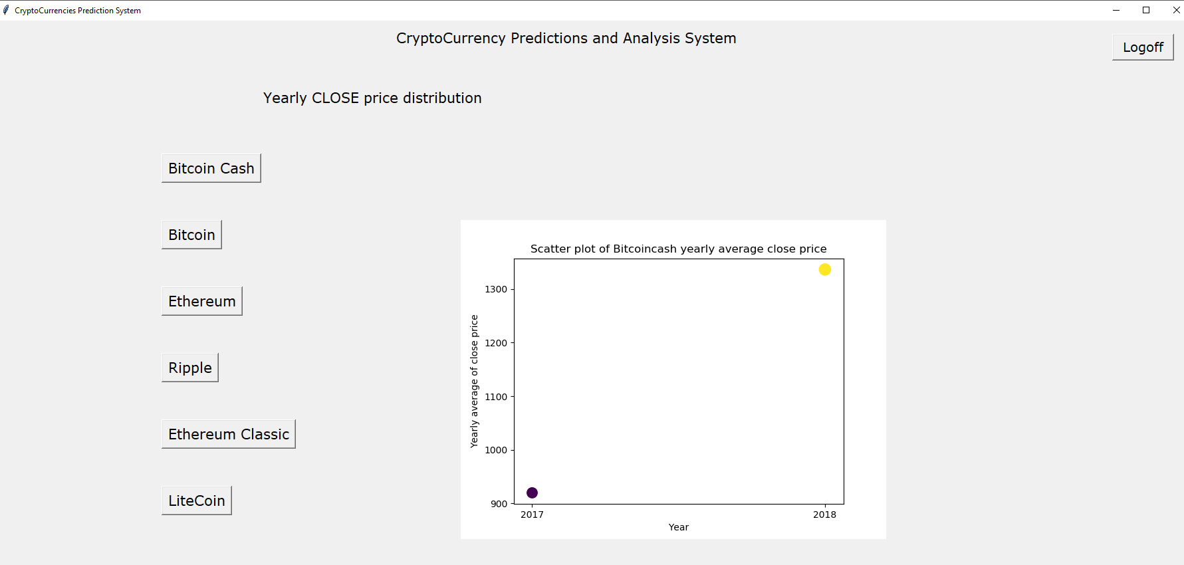

Bitcoin yearly distribution of close price

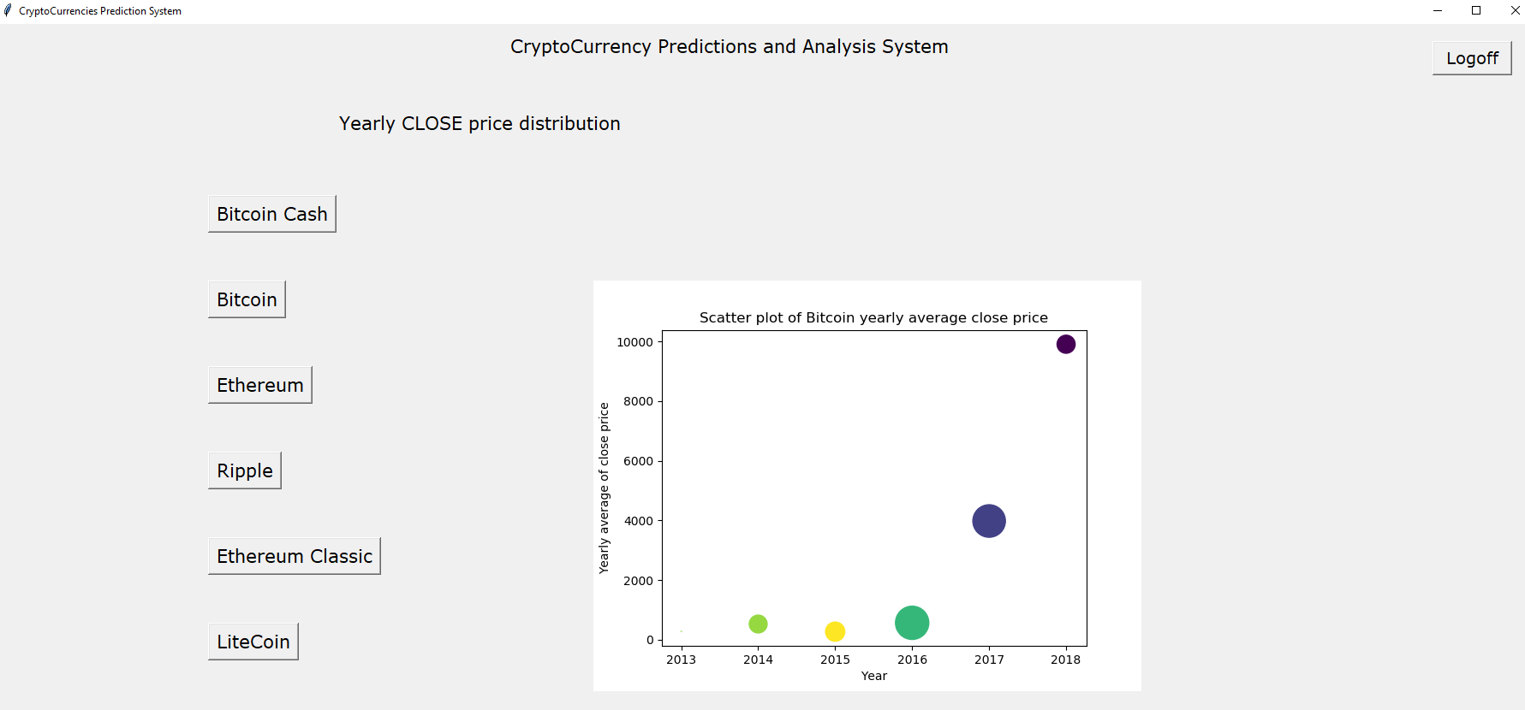

Clicking go back takes the user to the menu frame

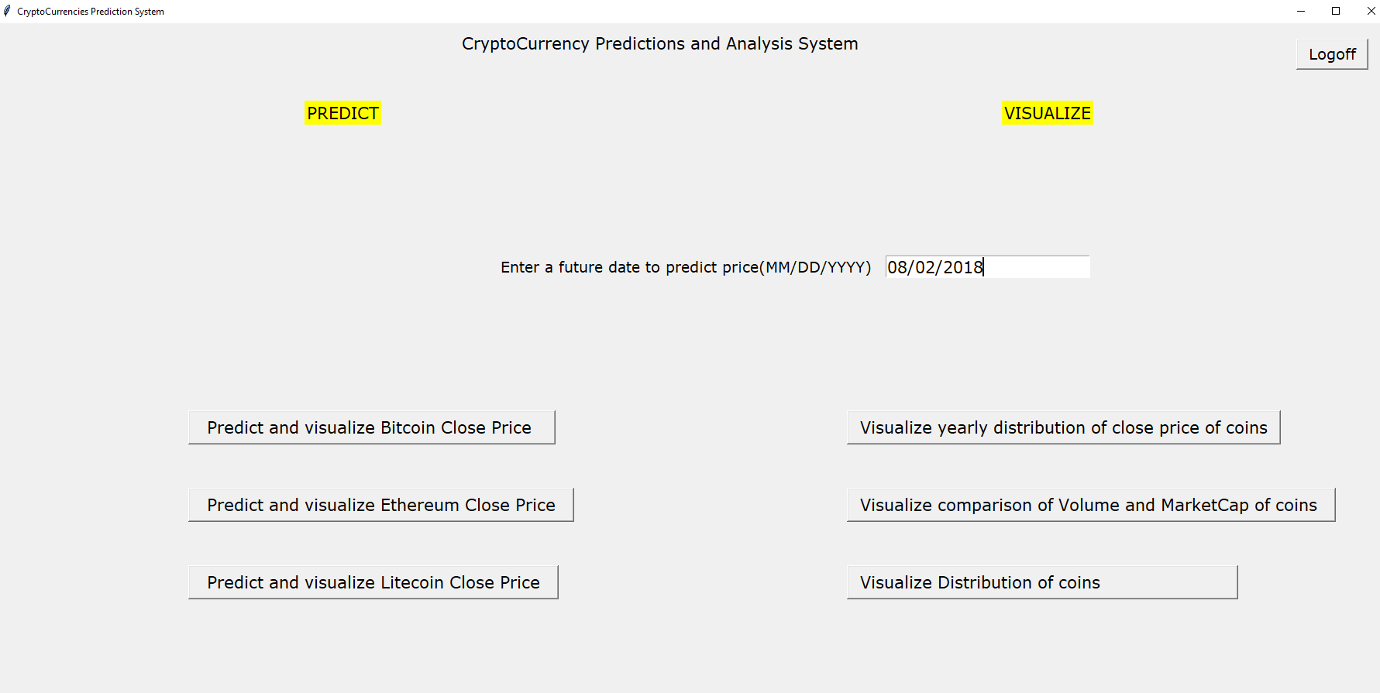

Visualize comparison of volume and market cap of coins:

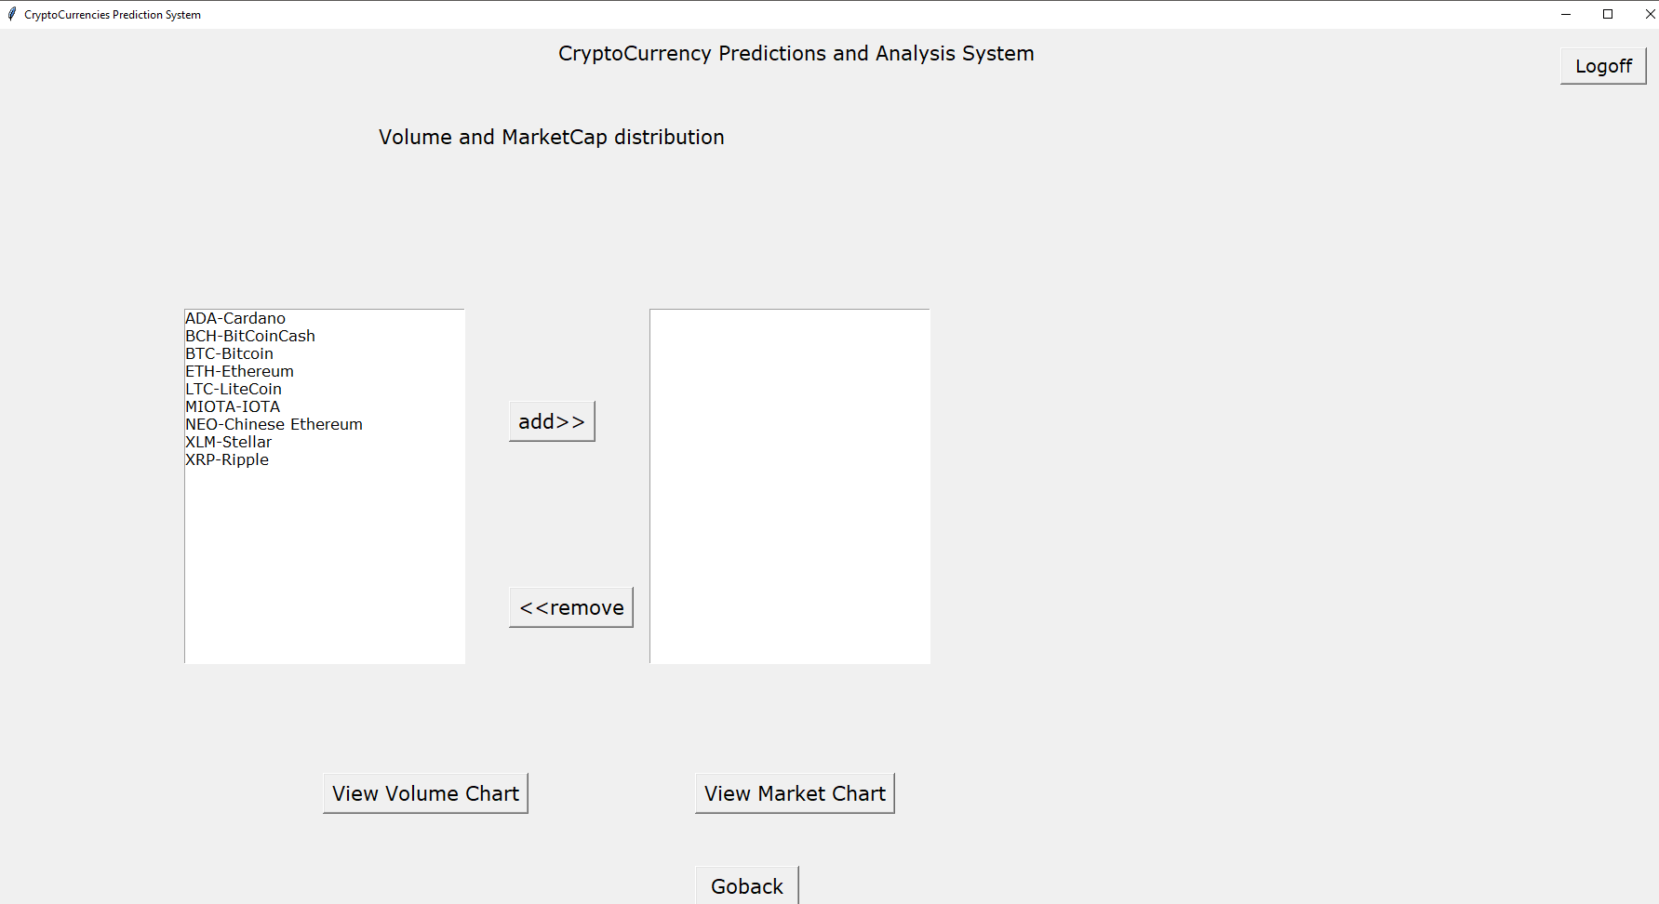

User can choose the different coins for which he wants to compare volume and market price. He can choose the coins, items and click either of the two chart buttons to view the respective charts

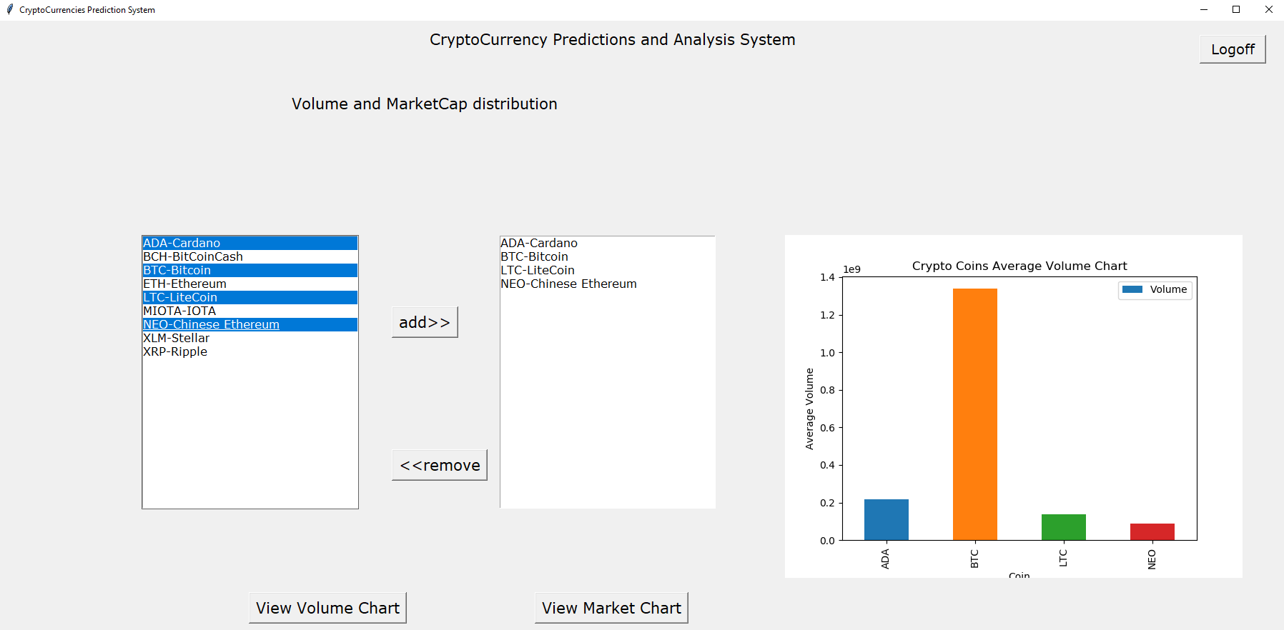

User can choose coin from right listbox and click remove to remove a coin from comparison as shown below

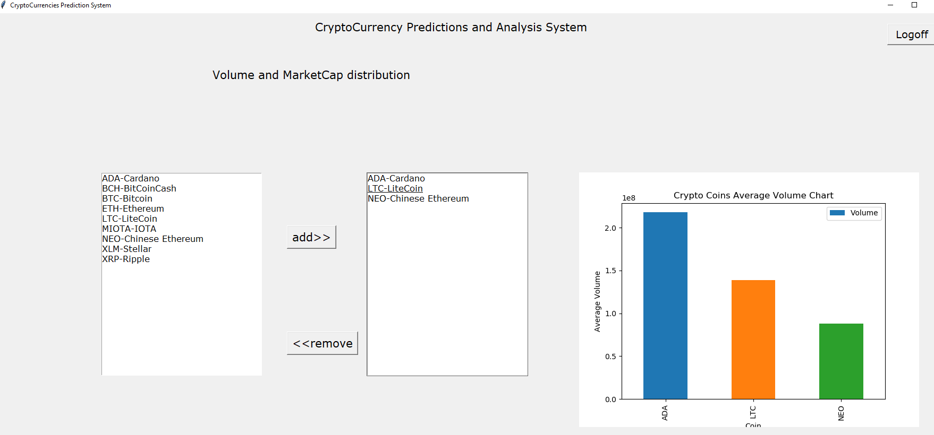

Market cap chart can be viewed by clicking the respective button

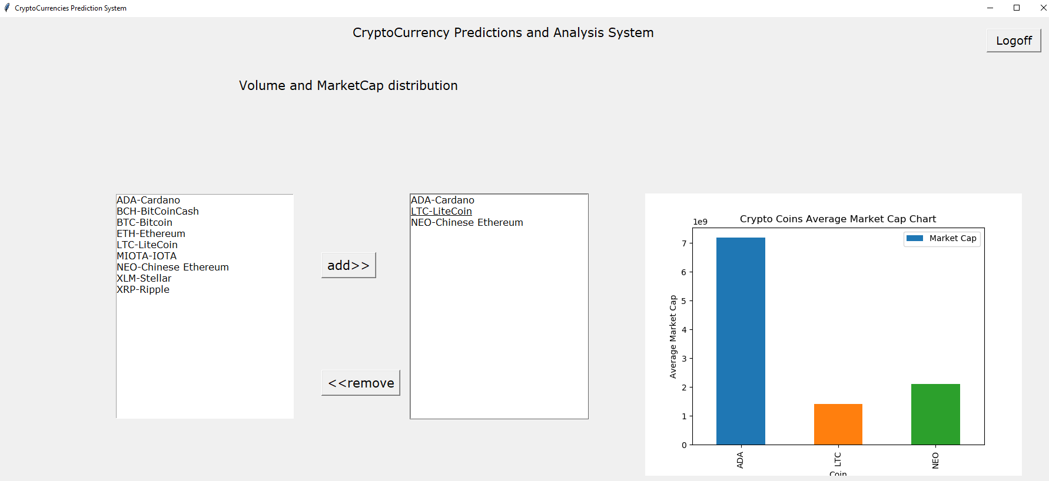

Clicking ‘go back’ takes the user to the menu frame



Visualize distribution of coins: clicking this button takes user to the below frame.

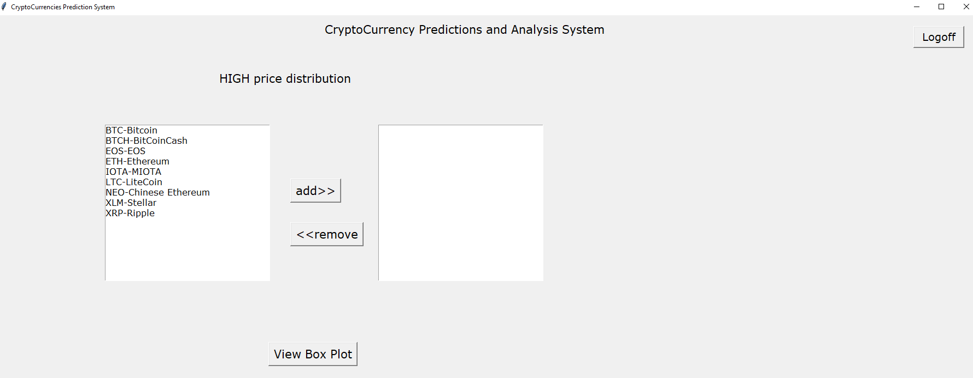

User can choose coins he wants to compare/view the HIGH price distribution of. Select the item from the left side list, click add button and then click ‘view box plot’ to generate box plot of the HIGH prices of coins chosen

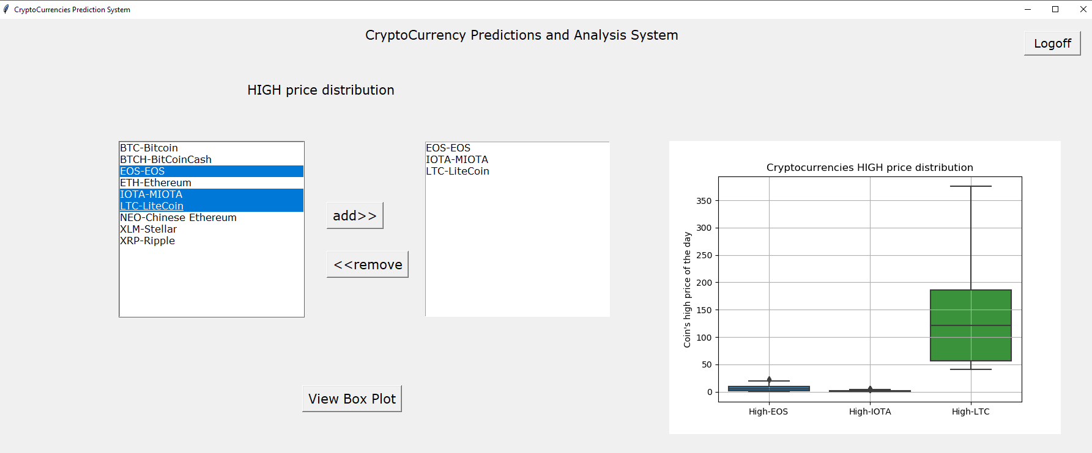

Removing an item and viewing the plot

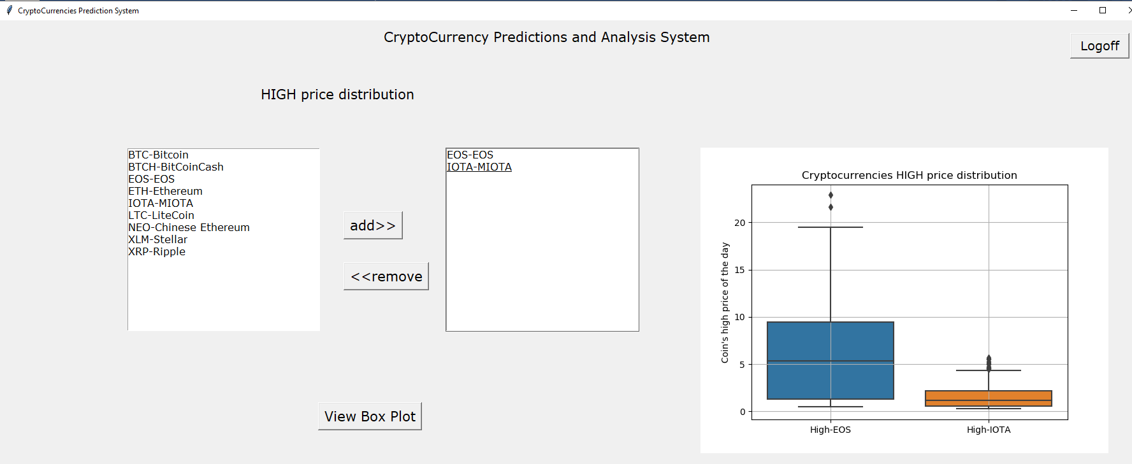

Different set of coins:

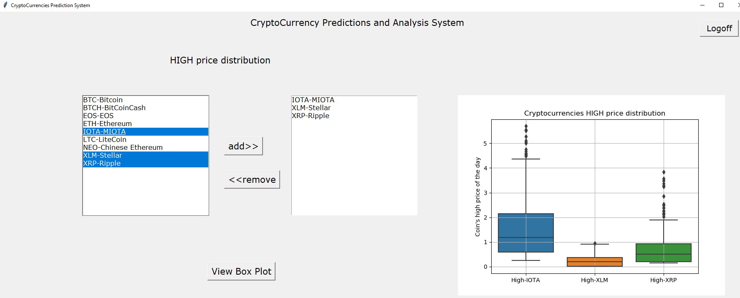

Clicking ‘Logoff’ button from any frame logs off the user from the system and takes the user to the login frame as shown below. It confirms the user before logging off

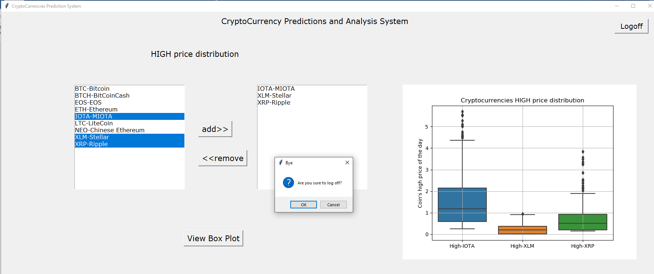

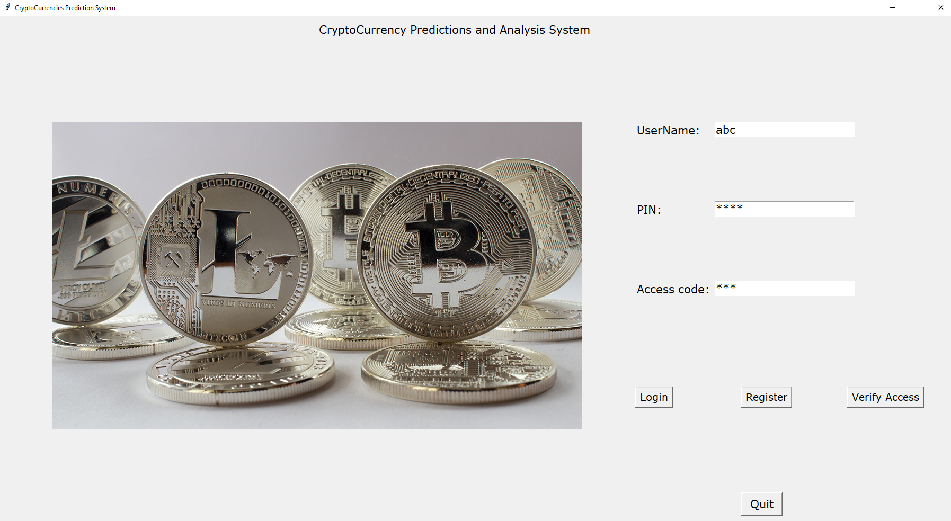

Clicking ‘quit’ button closes the application with a greeting as shown below

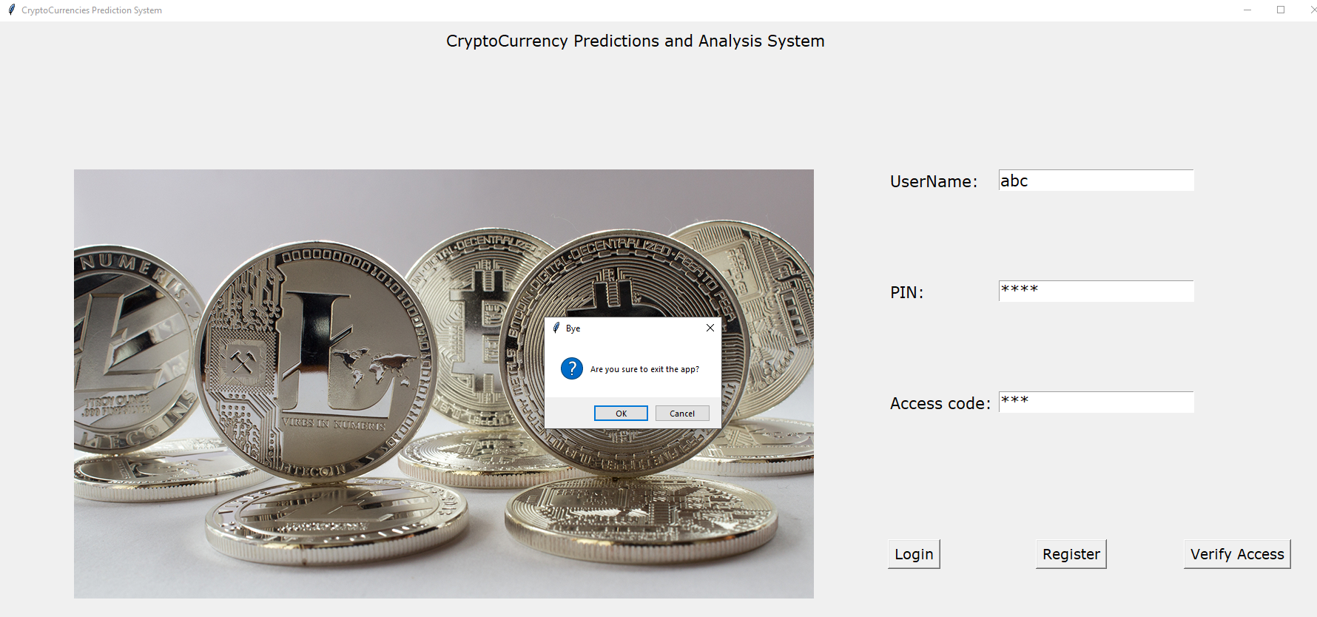

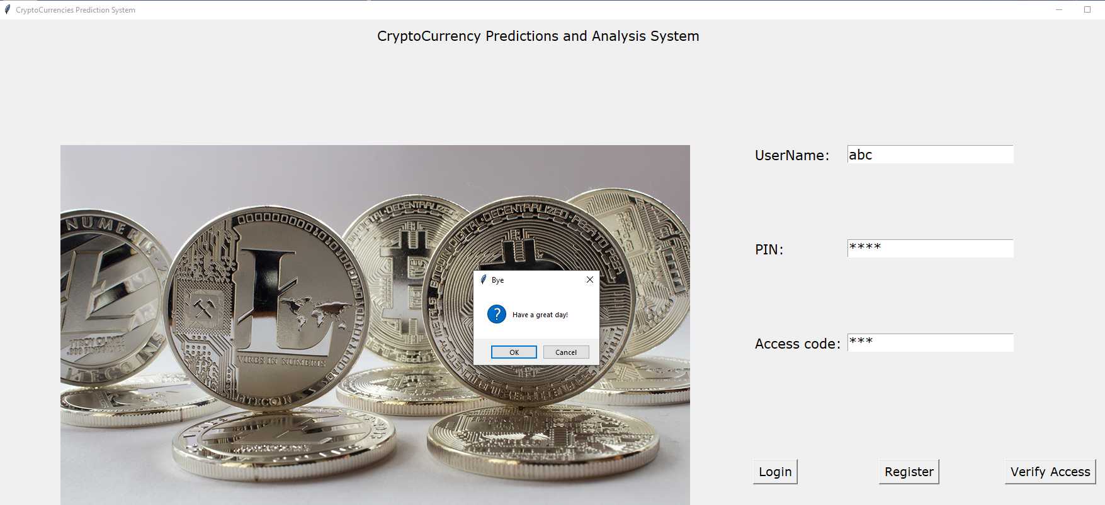

Register:

On clicking ‘register’ in the launch frame, the member registration frame opens up

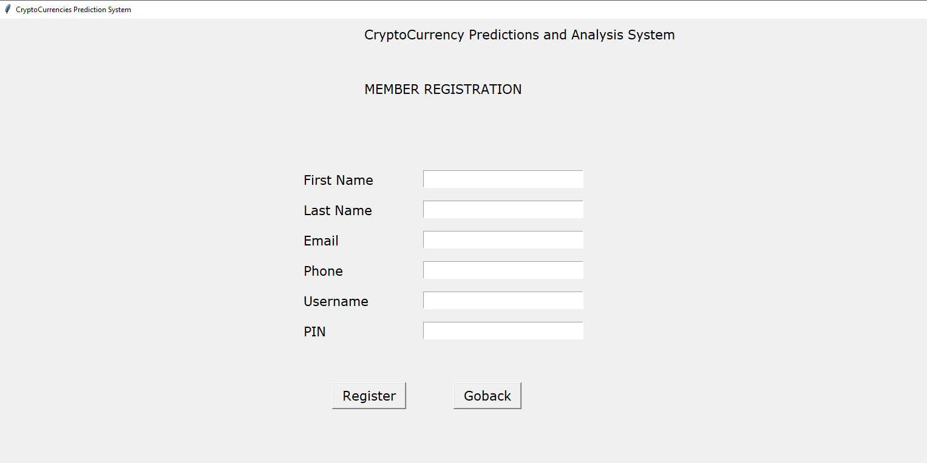

User clicks ‘register’ without entering any detail. He is prompted to enter the respective detail as shown below

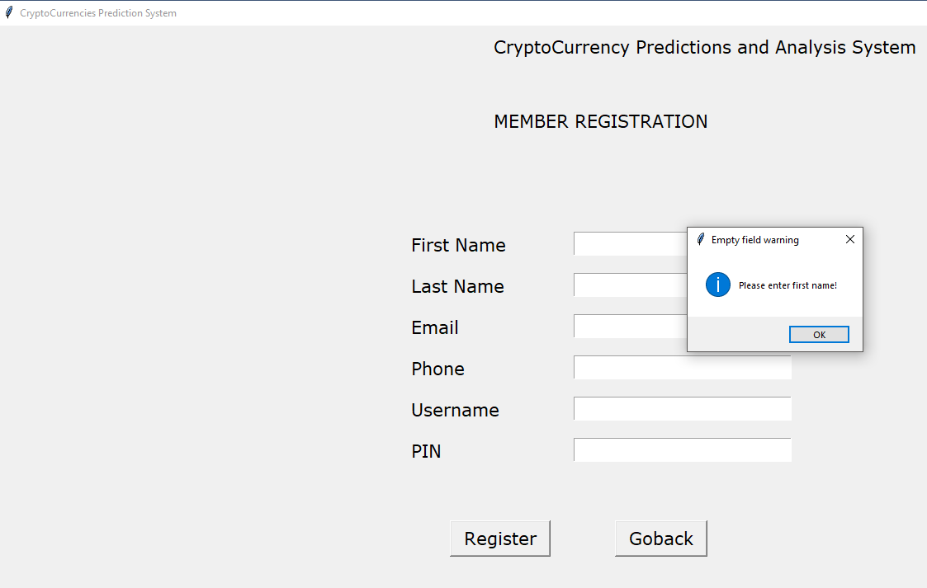

On entering just the first name and clicking register, he is asked to enter the next field value

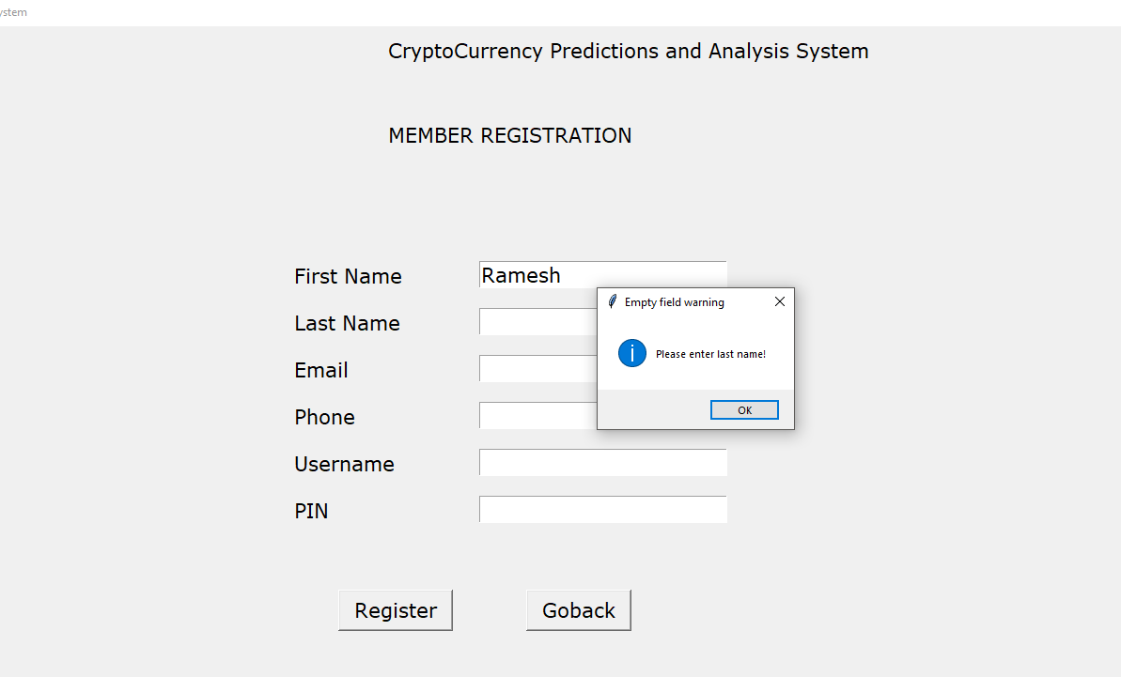

User enters first name and last name and clicks register. He is prompted to enter email

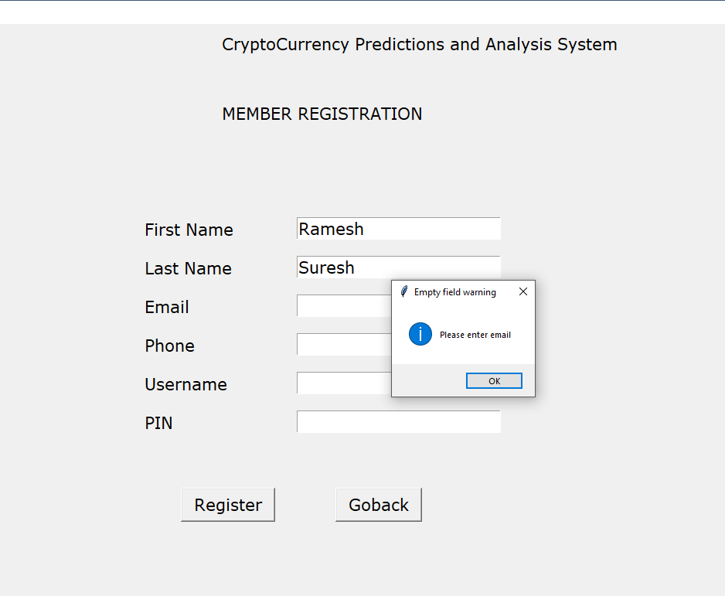

User then enters email and clicks register. He is prompted to enter the phone

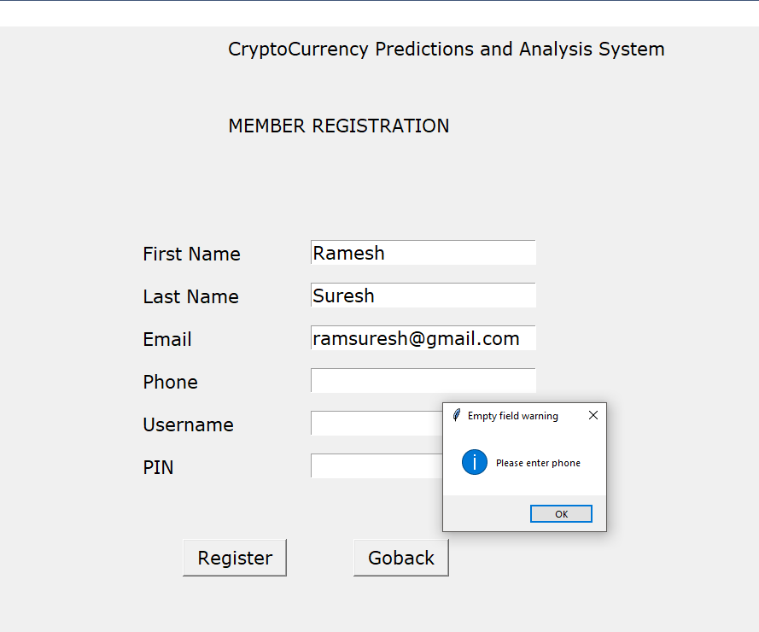

User enters phone and clicks register. He is prompted to enter his username

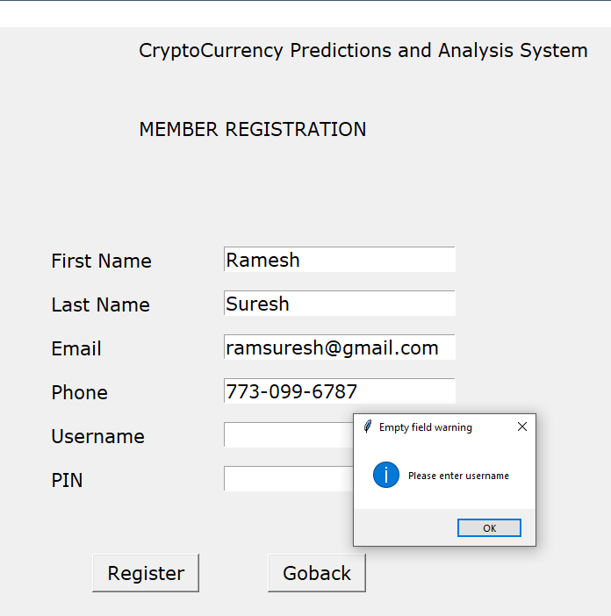

User enters username and clicks register. He is prompted to enter pin

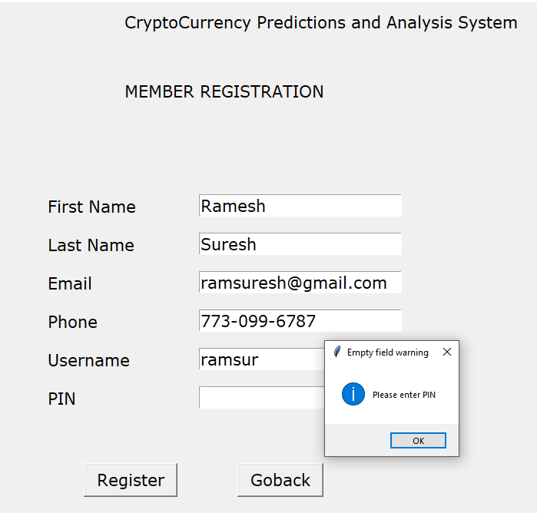

User has now entered all details as shown below

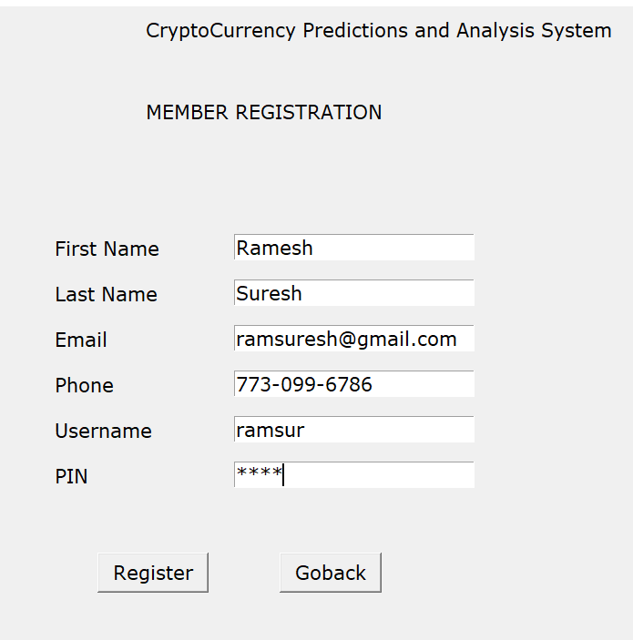

He now clicks register. He is notified that he is registered successfully

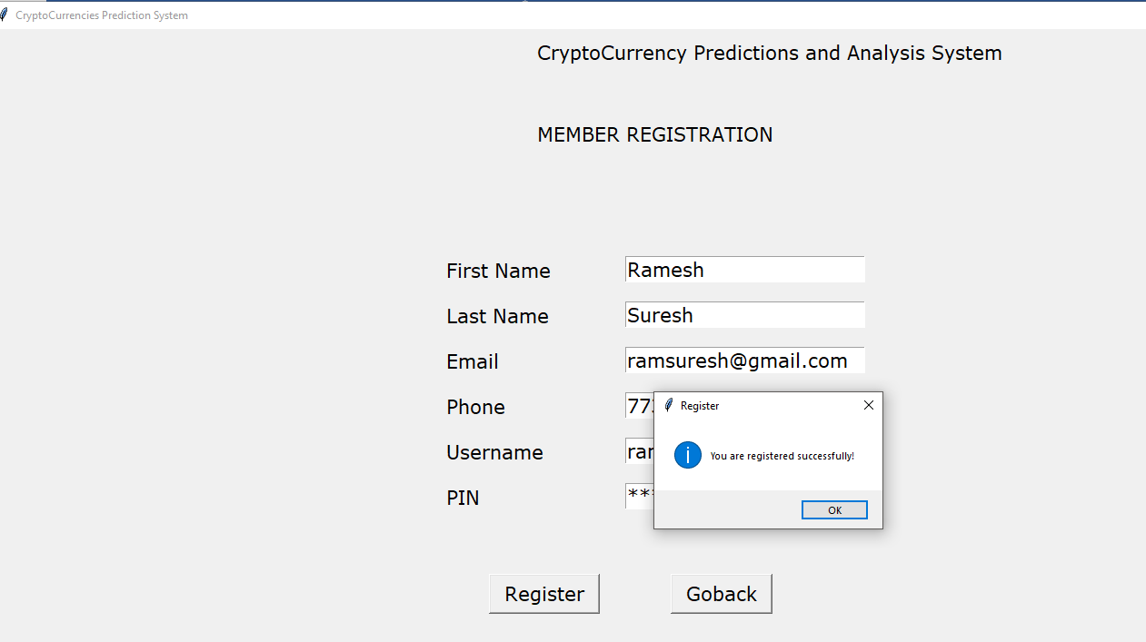

# **7. Extra-Credits**

**Jupyter notebook :**

Have written the driver module as a Jupyter notebook.

File: ‘FinalProj-Driver-v1.ipynb’

**Password Hashing:**

PIN entered by the user while registering is hashed and stored in SQLite Database

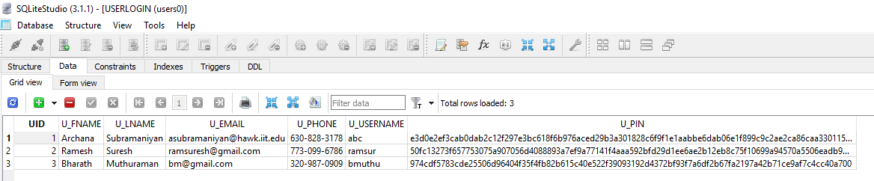

**Machine Learning:**

LSTM is a neural network model that uses tensor flow in the backend. LSTM model that is built for predicting bitcoin, Ethereum, Litecoin prices is built on train data and predicted on test data as explained earlier. Actual data is split in 70/30 ratio for train/test data respectively. Latest data is taken as test data the older data is taken as train data. Code is available in below files:

FinalProjBTCPred.py

FinalProjETHPred.py

FinalProjLTCPred.py

**Video walk-thru of the application**:

Video file is uploaded in blackboard in the zip file. It is also available in the below link

<https://drive.google.com/open?id=1nlbgIn0cMaM8--lj1pizm52NOI98KBtA>

# **8. Conclusion**

Cyrptocurrency prediction and analysis system is useful for predicting bitcoin, Ethereum and Litecoin. Visualization options help a user to generate charts and visualize the comparison of a metric of different coins

# **9. Limitation**

Since cryptocurrencies data are relatively new compared to other time dependent data like stock prices, monthly and yearly prediction would be difficult and if one prediction model is built for monthly/yearly data, the model accuracy will not be good too. It is because of this, monthly/yearly predictions are not carried out as part of this project.

# **10. Potential Improvements**

From the prediction results, we could see that the accuracy is better for Ethereum and Litecoin are better than that compared to bitcoin. The model must be trained more and more to fine tune the accuracy. This application just deals with prediction of 3 cryptocurrencies which number can be improved or extended to the top ten crypto coins at least. As years pass by, volume of data for monthly and yearly predictions would reach a satisfactory level which can then be used for yearly/monthly predictions